Technical solution

EKRAN

request for proposal for microwave ptp radios

TABLE OF CONTENTS

Par. Item Page
Executive summary 3
1. Introduction – Product portfolio 4
1.1. OmniBAS™ product family 5
1.2. INTRALINK™ product family 7
1.3. Unified Management System - uni|MS 8
2. OmniBAS Connectivity Applications 10
2.1. Nodal Solution 10
2.2. Ring Configuration 10
2.3. Traffic Aggregation 11
3. OmniBAS Advanced Features 13
3.1. Leading Radio Density 13
3.2. OmniBAS Product Family Deployment Flexibility 13
3.3. Environmental Friendly Design 13
4. Proposed Technical Solution for EKRAN 14
4.1. Microwave Main Backbone 14
4.2. Microwave Access Links 16
Conclusions 17

TABLE OF FIGURES

Figure 1: INTRACOM TELECOM product portfolio 4
Figure 2: OmniBAS™ product family 5
Figure 3: OmniBAS™ pseudowire transmission 6
Figure 4: INTRALINK™ product family 7
Figure 5: unified Management System layered architecture 9
Figure 6: OmniBAS Nodal solution 10
Figure 7: OmniBAS ring configuration 11
Figure 8: Traffic aggregation with OmniWay 2G 12
Figure 9: EKRAN MW radio topology 14
Figure 10: Central and remote nodes configuration 15
Figure 11: Transit nodes 1 and 2 configuration 15
Figure 12: Microwave Main Backbone solution 16
Figure 13: User sites 1 and 2 terminal configuration 16

Executive summary
INTRACOM TELECOM is a leading developer and producer of telecommunication systems as well as provider of integrated solutions and professional services to fixed and mobile operators in EEMEA and APAC region. We have been innovating in the wireless access and transmission field for over 15 years, having successfully developed and deployed point-to-point and point-to-multipoint systems with numerous operators in Europe, the Middle East, America, Asia and the CIS.
The Company has strategically focused and is investing heavily on the continuous evolution of its wireless product lines. Our expertise lies in delivering end-to-end integrated solutions, in implementing large-scale turnkey projects, and in providing a wide range of engineering, consulting, and outsourcing professional services. Dedication to R&D and commitment to technology innovation are fundamental components of our business strategy.
INTRACOM TELECOM operates more than 15 state-of-the-art research laboratories that drive the rapid development of high-quality, advanced telecommunications systems. We are proud to collaborate and have strategic alliances with some of the best companies in the world, conducting joint research and developing tomorrow’s products and services.
Through this proposal INTRACOM TELECOM provides to EKRAN a complete range of product equipment, and technical consultation, in order to ensure that the solution will be cost effective, integral and covers all possible needs/requirements that already exist or may be presented during the implementation of the project.
INTRACOM TELECOM will provide Point-to-Point products from the OmniBAS MW radio product family, as well as associated antennae and installation accessories for the proper Deployment of the network.

We are committed to the enhancement of the network infrastructure and operations / business support systems of our customers, supporting them in achieving excellence in their business demands, improving their competitiveness, increasing their operational efficiency, and enhancing their customer service.

Introduction – Product portfolio
The Company has strategically focused and is investing heavily on the continuous evolution of its wireless product lines. In the growing shift to broadband, IP based converged networks, INTRACOM TELECOM is incorporating the latest standards and state-of-the-art technologies in order to deliver cost-effective wireless solutions that address the new requirements of its customers.

- Native Packet Point-to-Point and Nodal Transmission (OmniBAS™, OmniWay)
- Native Ethernet and TDM PDH/super-PDH/SDH/Ethernet Point-to-Point Microwave Links (INTRALINK™)
- Multiservice Point-to-Multipoint Wireless Transmission and Access (WiBAS™)
- Wireless Broadband Access, WiMAX (OmniMAX™)

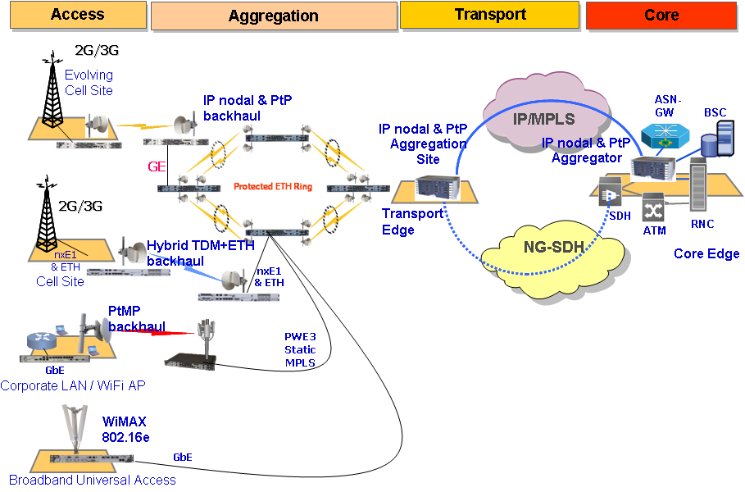
Figure 1: INTRACOM TELECOM product portfolio
The emergence of mobile broadband and multimedia services, the enhancement to the air interfaces (HSPA+, LTE, CDMA EV-DO, WiMAX) and the upcoming saturation of ARPU for voice, shape today’s mobile market and technology landscape. Operators are faced with increased capacity demands, which put stress on their transport / backhaul networks. To overcome, they have to either spend on expanding their existing networks, or spend on new, more efficient solutions.

INTRACOM TELECOM’s wireless point to point product portfolio consists of two product families:
- OmniBAS™
- INTRALINK™

OmniBAS™ product family
OmniBAS™ is a native Ethernet wireless transmission and nodal platform employing the latest microwave technology. It achieves traffic throughputs of up to 400 Mbit/s over a single link (or up to 800 Mbit/s with XPIC) with channelization up to 56 MHz.
OmniBAS™ incorporates statistical multiplexing for best optimization of the available link capacity, and adaptive modulation – QPSK up to 256QAM – for increased service availability at all weather conditions.

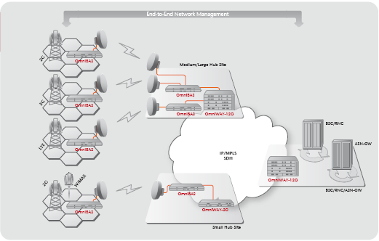
Figure 2: OmniBAS™ product family
The OmniBAS product family provides great flexibility, for various network deployment scenarios. OmniBAS consists of a product family that provides numerous solutions:
- OmniBAS-4W. Its leading radio density allows OmniBAS-4W to be used in several network deployments
  - Small / Large Aggregation Hubs (2+2/4+0 or multiples)
  - Ring nodes with carrier class ITU G.8032 ring protection functionality
  - Repeater nodes with large capacity links (2+0/1+1), east-west functionality from a single 1U unit
- OmniBAS-2W. The ability of the unit to provide up to 2 radio modems allows OmniBAS-2W to be used in several network deployments
  - Edge nodes with 1+0/1+1/2+0 connectivity, offering up to 400Mbps per link
  - Repeater nodes with 1+0 links, east-west functionality from a single 1U unit
- OmniWay-2G. The legacy aggregation capabilities make OmniWay-2G a perfect fit for
  - Low Aggregation deployments to provide STM-1 interfaces to the core SDH network
  - Legacy Aggregation deployments to aggregate legacy traffic from existing TDM-based transport networks.

In cases of high aggregation of traffic at large hub sites, OmniBAS provides advanced aggregation and interworking, with the use of OmniWay units.
OmniBAS product family can effectively interwork with existing SDH networks when needed. The legacy traffic is transformed into packet traffic for its transportation over the OmniBAS network cloud, and when it needs to be provided as TDM/ATM, OmniBAS transforms it from packet back to legacy.
OmniBAS-4W/2W provides legacy directly as E1 interfaces, and through STM-1 interfaces for high traffic concentration with the use of OmniWay units.

OmniBAS enables operators to take an evolved approach and smoothly migrate to all-IP, for delivering new compelling services along with serving more customers without additional expenditures. Incorporating highly efficient traffic handling mechanisms and bandwidth utilization techniques, OmniBAS assures carrier class service delivery with highest availability.
Backhaul of legacy services is carried out seamlessly through Pseudo-Wire (PW) functionality (as shown in figure 4) and through the utilization of E1, STM-1 (VC-12), and Gigabit Ethernet network interfaces.

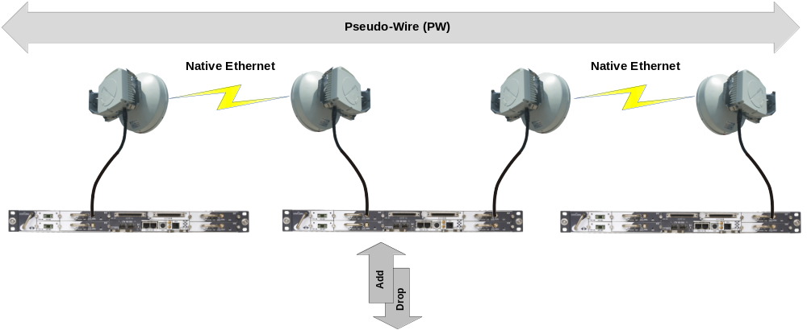
Figure 3: OmniBAS™ pseudowire transmission
OmniBAS Main Features
- Native ETH-based Point-to-Point radio with statistical multiplexing
- Up to 1.6 Gbit/s from a single 1RU chassis
- Nodal configurations with four radios per 1 RU chassis
- QoS to fully support all classes of traffic
- Up to 256 QAM adaptive modulation for optimum bandwidth utilization and lower CapEx & OpEx
- High full-duplex throughput over a single channel: up to 400 Mbit/s, up to 800 Mbit/s with XPIC
- Pseudo-Wire (PW) over ETH for multiservice transmission
- ETH ring protection (ITU-T G.8032)
- Intuitive graphical management (SNMP)

OmniBAS provides a complete and homogeneous MW PTP transmission and aggregation portfolio (OmniBAS-OmniWay) that scales from end sites to small and large aggregation sites, providing both advanced networking functionality and simplicity to manage effectively the traffic. INTRACOM TELECOM monitors continuously developments in industry and customer requests and evolves accordingly its products to remain always on the cutting edge of technology.

INTRALINK™ product family
INTRALINK™ comprises a homogeneous family of Point-to-Point (PtP) digital microwave products that fit a wide range of transport and backhaul applications. Employing advanced hybrid technology to efficiently transport legacy (PDH & SDH) and packet-based (Ethernet) traffic, INTRALINK™ allows cost-effective backhaul at both
the last mile and high-density aggregation sites.
INTRALINK™, a rich-featured and future-proof platform designed to meet operators’ most stringent demands, also offers high capacities and unparalleled flexibility to support complex network architectures.
With the ability to simultaneously handle any mix of TDM and packet-based traffic, INTRALINK™ is a long-lasting investment enabling smooth migration from pure TDM to pure packet services.
The figure below depicts typical applications and network topologies, enabled by INTRALINK™ ISR and IDR-LC systems, for mobile & WiMAX backhaul, private networks and PtMP access backhaul.

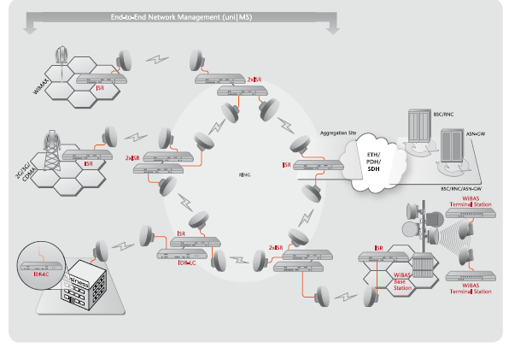
Figure 4: INTRALINK™ product family
INTRALINK™ is a split system mainly composed of a compact 1RU indoor unit (ISR, IDR-LC) and the outdoor radio units (ODU) with integrated antennas. Offering a variety of legacy PDH / SDH and Ethernet interfaces, and allowing flexible fault-tolerant configurations, INTRALINK™ covers a wide range of demanding backhaul & transport applications. Its rich features (Ethernet QoS, integrated add/drop multiplexer, native SDH transmission, etc.), allow the realization of complex network architectures. Regarding the management of INTRALINK™ systems over existing third-party equipment, INTRACOM TELECOM’s i-converter assures interoperability with multiple vendors.

ISR main features:
- Modular and compact (1RU)
- Native Ethernet and Native TDM solution
- Cost effective design with hot swappable modules
- Pay as you grow capacity expansion
- Ethernet QoS
- Up to 63xE1 interfaces in a 1RU.
- PDH / SDH ring protection
- RSTP support for ETH port protection
- Single chassis configurations with two modems:
  - 1+1 (HSBY/FD/SD)
  - 2+0 East / West, for repeater stations or ring deployments
  - 2+0 East / East for maximum traffic throughputs
- XPIC (Cross – Polarization Interference Cancellation) – with OmniBAS 4W
- Embedded add/drop multiplexer
- 256QAM
- Up to 56MHz radio channel

Unified Management System - uni|MS
Introduction
INTRACOM TELECOM’s unified management system - uni|MS is a unified, high-scale and carrier-class Element, Network and Service Management suite for all INTRACOM TELECOM products, wireless and wireline, as well as for third party products through add-on drivers.
uni|MS can be used as a single management platform when multiple INTRACOM wireless and/or wireline products are deployed, or as standalone platform for INTRALINK™/OmniBAS™ networks.

Solution Features
The INTRACOM TELECOM Network Management Proposed Solution provides the Operator with:
- Fulfillment
  - Fast and easy deployment of network services to customers
  - Efficient configuration of network elements
- Assurance
  - Advanced network surveillance, filtering, logging and reporting capabilities
  - Efficient supervision and consistent management of network resources
  - Visualized real-time status monitoring with business-oriented graphical interface hiding the underlying network complexity
  - Collection and processing of performance and traffic measurements
- Operations
  - Automatic network discovery and presentation
  - Centralized firmware and software download
  - Network Elements Configuration backup and restore
  - Inventory Information collection

uni|MS System Architecture
Conforming to TMForum’s guidelines, uni|MS functionality comprises of the following layers, as shown in figure 5:
- Element Mediation layer, which provides the communication with the managed elements for applying management functions. Each element type has its own driver; multiple drivers may run concurrently in the same uni|MS server.
- Domain Management layer, which implements FCPS (Fault - Configuration - Performance - Security) management functions on multiple element types belonging to a technology domain (wireless backhaul domain, WiMAX domain, wireline access domain, etc.).
- Resource Management layer, which provides cross-domain management capabilities such as status management, report management and sub-network connection management.
- Service Management layer, which implements service provisioning and activation functions, via a service agnostic workflow (BPEL) and a design environment, for realizing rapid service provisioning of GSM, CDMA, VoIP, xDSL, IPTV, IMS services.
- Client layer, which consists of multiple clients running the Graphical User Interface (GUI) concurrently; the clients enable authorized users to interact with uni|MS.

The unified Management System architecture is provided in the following figure

Figure 5: unified Management System layered architecture

OmniBAS Connectivity Applications

Nodal Solution
A typical nodal configuration for a mobile 2G/ 3G/ LTE network is shown in the following schematic:
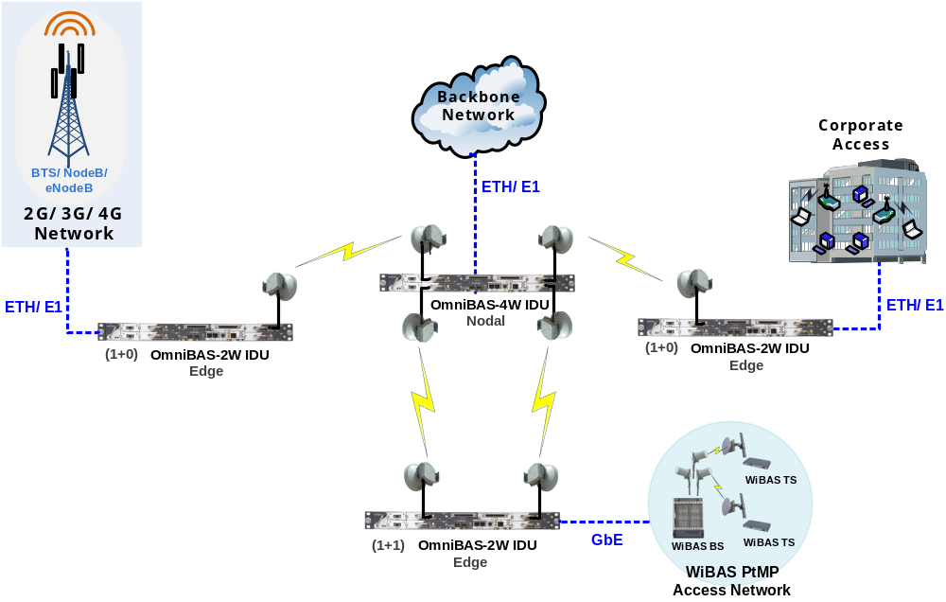
Figure 6: OmniBAS Nodal solution
In this example, three OmniBAS-2W IDU systems (at the edges of the network) and one OmniBAS-4W IDU system (at the nodal station) are used.
The nodal OmniBAS aggregates TDM / ATM / Ethernet traffic from a BTS/ NodeB/ eNodeB site, a PtMP access network and a large corporation, and forwards it toward the Ethernet and legacy networks.
As the schematic shows, two edge OmniBAS systems are configured for 1+0 unprotected operation and the third edge OmniBAS system is configured for 1+1 protected operation. Thus, the nodal OmniBAS is configured for 2 x (1+0) and 1+1 operation.
At the nodal station, several indoor units can be stacked to serve higher nodal requirements.

Ring Configuration
A typical ring configuration for a mobile 2G/ 3G network is shown in the following schematic
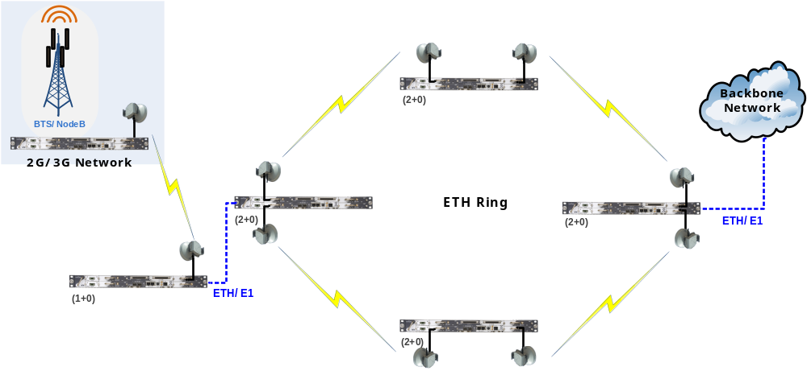
Figure 7: OmniBAS ring configuration

In this example, several OmniBAS-4W IDU systems implement a native Ethernet ring, as defined in the ITU-T G.8032 specification.
Each OmniBAS-4W system is configured for 2+0 operation, while one of them (the one shown at the right) is used for forwarding traffic toward the backbone network.
At any point in the ring, each OmniBAS can aggregate other sites through its spare radio units, or add/drop ETH and E1 traffic.

G.8032 Features
- Protection and recovery switching within 50 ms
- Efficient bandwidth utilization of ring traffic
- Automatic reversion mechanism upon fault recovery
- Frame duplication and reorder prevention mechanisms
- Loop prevention mechanisms
- Use of different timers (WTR timer, Hold-off timers) to avoid race conditions and unnecessary switching operations

Traffic Aggregation
In cases of high aggregation of traffic at hub sites, OmniBAS provides advanced aggregation and interworking, with the use of OmniWay units.
OmniBAS product family can effectively interwork with existing SDH networks when needed. The legacy traffic is transformed into packet traffic for its transportation over the OmniBAS network cloud, and when it needs to be provided as TDM/ATM, OmniBAS transforms it from packet back to legacy.
OmniBAS-4W/2W provides legacy directly as E1 interfaces, and through STM-1 interfaces for high traffic concentration with the use of OmniWay units.
One OmniWAY-2G is used for aggregating legacy traffic from two OmniBAS-4W/ 2W IDU systems. The interconnection with the OmniWAY-2G is realized through the one available GbE interface of each OmniBAS-4W/-2W system.
The OmniWAY-2G subrack:
- Aggregates packet traffic (from the OmniBAS-4W/ 2W IDU systems) through its GbE interfaces
- Internally converts packets (associated with legacy traffic) to stream, which is forwarded toward the SDH network through the STM-1 interfaces

The OmniBAS-4W/ 2W IDU systems internally switch and forward packets (associated with Ethernet traffic) toward the IP/MPLS network through the second GbE interface.

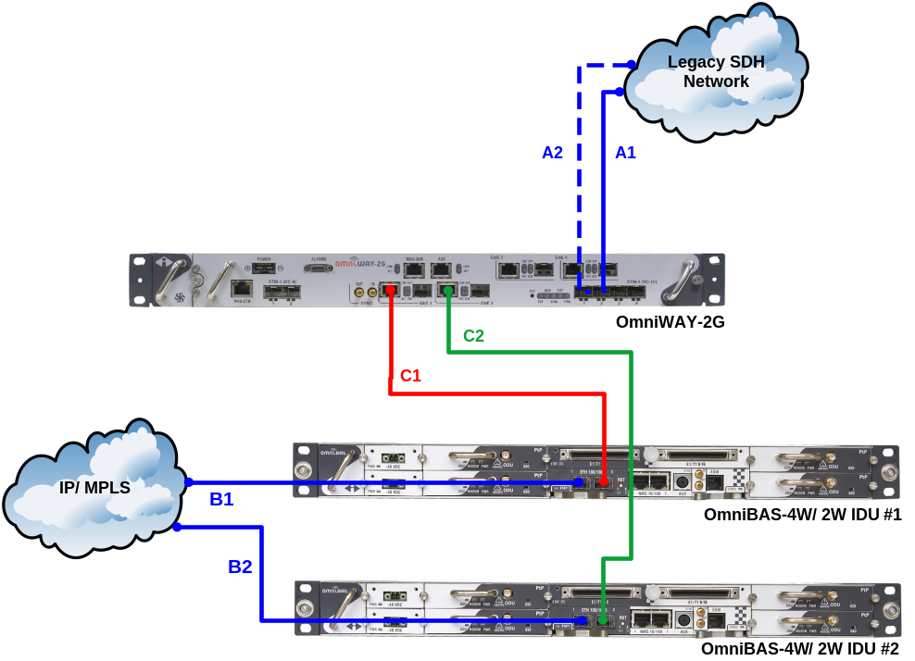
Figure 8: Traffic aggregation with OmniWay 2G

Cabling | Description
A1 | Uplink working path towards legacy SDH network (through STM-1/ VC-12 interface of the OmniWAY-2G)
A2 | Uplink protected path towards legacy SDH network (through STM-1/ VC-12 interface of the OmniWAY-2G)
B1/ B2 | Uplink GbE connections toward the IP/MPLS network for Ethernet traffic
C1/ C2 | GbE interconnections for carrying packets (associated with legacy-only traffic) toward the OmniWAY-2G

OmniBAS Advanced Features

Leading Radio Density
OmniBAS product family provides up to 4 radio modems in 1U chassis. This feature makes OmniBAS a leader in radio modem density (number of radio modems in 1U).
This feature provides advantages to operators, since OmniBAS requires minimum rack space to deliver high aggregation of radio links.
Leading radio density makes OmniBAS an ideal platform for nodal type site solutions, perfectly fitting small and large aggregation hubs. Furthermore, OmniBAS small form factor, allows for effortless expansion; a single 1U unit addition provides 4 extra radio modems in the aggregation hub.

OmniBAS Product Family Deployment Flexibility
The OmniBAS product family provides great flexibility, for various network deployment scenarios. OmniBAS consists of a product family that provides numerous solutions:
- OmniBAS-4W. Its leading radio density allows OmniBAS-4W to be used in several network deployments
  - Small / Large Aggregation Hubs
  - Ring nodes with proven G.8032 functionality
  - Repeater nodes with large capacity links (2+0/1+1), east-west functionality from a single 1U unit
- OmniBAS-2W. The ability of the unit to provide up to 2 radio modems allows OmniBAS-2W to be used in several network deployments
  - Edge nodes with 1+0/1+1/2+0 connectivity, offering up to 400Mbps per link
  - Repeater nodes with 1+0 links, east-west functionality from a single 1U unit
- OmniWay-2G. The legacy aggregation capabilities make OmniWay-2G a perfect fit for
  - Low Aggregation deployments to provide STM-1 interfaces to the core SDH network
  - Legacy Aggregation deployments to aggregate legacy traffic from existing TDM-based transport networks.

Environmental Friendly Design
Intracom Telecom has designed the OmniBAS platform in an environmentally friendly way. OmniBAS power dissipation and consumption are kept to low levels, to allow green transport operation and OPEX savings for the operator.
- The maximum power consumption of the OmniBAS-2W unit is 46W for a 1+1 configuration
- The maximum power consumption of the OmniBAS-4W unit is 87W for a 2+2 configuration
- OmniBAS ODUs consume 21W- 34W, depending on the operating frequency

Proposed Technical Solution for EKRAN
This section describes the complete technical solution for the supply of MW Equipment for EKRAN.
The following figure depicts the MW radio topology required by EKRAN. This topology consists of two parts:
  - Microwave main backbone – Frequency of operation is 7GHz
  - Microwave Access links – Frequency of operation is 7GHz
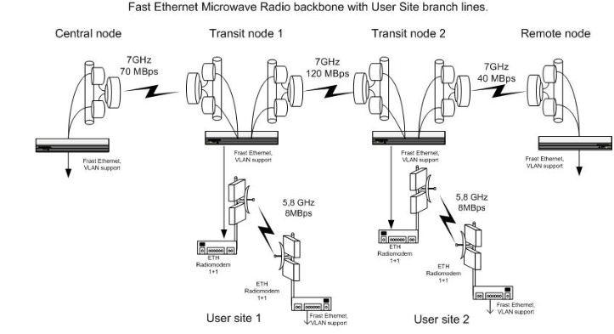
Figure 9: EKRAN MW radio topology
The actual requirements of the MW system for the main backbone are the following:
- Hot Standby configuration in all nodes
- 120Mbps throughput capacity

Microwave Main Backbone
The OmniBAS™ proposed solution for the central and remote nodes will be realised via OmniBAS 2W configured in 1+1 Hot Standby. 4xFE and 1GbE along with 8E1 ports are provided.
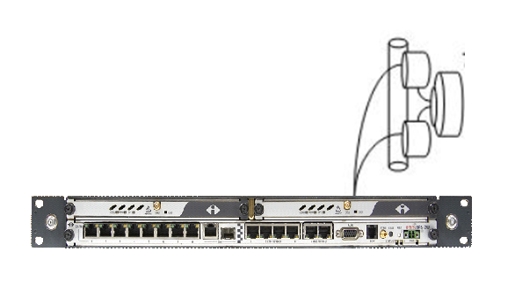
Figure 10: Central and remote nodes configuration
The proposed solution for transit nodes 1 and 2 will be realized via OmniBAS 4W configured in 2+2 Hot Standby as shown in the following figure:

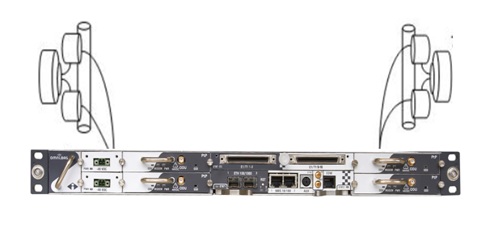
Figure 11: Transit nodes 1 and 2 configuration
Each transit node consists of an IDU, configured in 2+2 diversity, and two integrated couplers hosting a pair of ODU. 2xGbE ports and 16E1s are offered in each of the transit nodes 1 and 2. A single IDU solution offers a high concentration point (nodal) of 4 direction in a single 1U.

The complete solution for microwave main backbone is illustrated in the following figure:
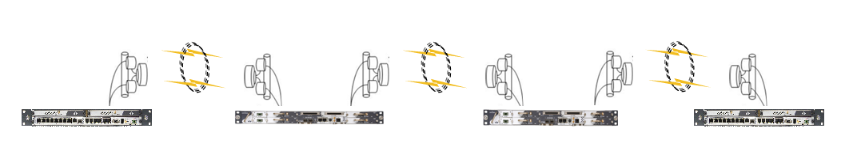
Figure 12: Microwave Main Backbone solution

Microwave Access Links
The OmniBAS™ proposed solution for the microwave access links will be realised via OmniBAS 2W configured in 1+1 Hot Standby. 4xFE and 1GbE along with 8E1 ports are provided.
Figure 13: User sites 1 and 2 terminal configuration

Each access link consists of two terminals both of which are configured as shown in the above figure. The first terminal of the user link will be located in the Transit node and shall be connected to the Transit node OmniBAS 4W terminal back to back via a fast Ethernet cable. The second terminal shall be situated at the user site.

Conclusions
The advanced OmniBAS™ portfolio modularity and its state of the art technology offering, provide EKRAN with a powerful set of advantages for the robust and efficient deployment of its packet MW network:

OmniBAS™ offering:
- OmniBAS market leading radio density
- Proven, robust and hitless adaptive modulation and statistical multiplexing
- Portfolio versatility for cost-efficient deployment and seamless integration

INTRACOM TELECOM proposes an end-to-end solution to EKRAN through the OmniBAS™ product family for an efficient and reliable network.

