TDM Service over Packet Networks

PoC Template #3

|  |  |
| --- | --- |
| Last Updated: | Jan 30, 2015 |
| Doc. Version: | 1.0 |
| Doc. Owner | Ronen Rick |

Contents

1. Introduction 4

1.1. Purpose 4

1.2. Layout Overview 4

1.2.1. Application Diagram 4

1.2.2. Devices under Test 5

1.2.3. Devices Under Test 6

2. Preliminary Configuration and Management 7

2.1. Setting SDH 7

2.1.1. Setting ETX-5 Aggregation POP 7

2.1.2. ETX-205 HQ Preliminary Setting 7

2.1.3. IPmux-24 Preliminary Setting 8

2.1.4. LA-210 Preliminary Setting 8

2.1.5. MiTOP Preliminary Setting 8

2.2. Devices Preliminary Setting – SONET (OC-3) 9

2.2.1. ETX-5 Aggregation POP Preliminary Setting 9

2.2.2. ETX-205 HQ Preliminary Setting 9

2.2.3. IPmux-24 Preliminary Setting 9

2.2.4. MiTOP Preliminary Setting 10

3. TDM Service Provisioning and Testing 11

3.1. TDM Services STM-1 – CESoPSN, UDP/IP between Edge Endpoints 11

3.1.1. Test Case 1: PW1-4 between Aggregation POP to IPmux-24 11

3.1.2. Test Case 2: PW5-8 between Aggregation POP to HQ, ETX-205 12

3.1.3. Test Case 3: PW9 between Aggregation POP and MiTOP(E1) 13

3.1.4. Test Case 4: PW10 between Aggregation POP to LA-210 14

3.2. TDM Services OC-3 – SAToP, MEF8 between Edge Endpoints 16

3.2.1. Test Case 1: PW1-4 between Aggregation POP to IPmux-24 16

3.2.2. Test Case 2: PW5-8 between Aggregation POP to HQ, ETX-205 17

3.2.3. Test Case 3: PW9 between Aggregation POP to MiTOP (T1) 18

A. Appendix A – STM1 20

A.1. Aggregation POP – ETX-5 Preliminary Setting 20

A.2. HQ – ETX-205 Preliminary Setting 23

A.3. IPmux-24 – Management, TDM type and Mux Method Setting 25

A.4. LA-210 – Preliminary Setting 32

A.5. MiTOP – Preliminary Setting 34

B. Appendix B – SONET (OC-3) 35

B.1. Aggregation POP – ETX-5 Preliminary Setting 35

B.2. HQ - ETX-205 Preliminary Setting 39

B.3. IPMUX-24 – Management, TDM type and Mux Method Setting 42

B.4. MiTOP – Preliminary Setting 49

Appendix C – IEEE 1588v2 Frequency Synchronization ( 52

C. SDH and SONET) 52

C.1. ETX-5 Master Configuration 52

C.2. ETX-205 Slave Configuration 53

D. Appendix D – SDH – CESoPSN (UDP/IP) Services 55

D.1. ETX-5 ↔ IPMUX-24 Services Configuration 55

D.2. ETX-5 ↔ ETX-205 Services Configuration 62

D.3. ETX-5 ↔ MiTOP Services Configuration 67

D.4. ETX-5 ↔ LA-210 Services Configuration 72

E. Appendix E – SONET – SATOP (MEF 8) 74

E.1. ETX-5 ↔ IPmux-24 Services Configuration 74

E.2. ETX-5 ↔ ETX-205 Services Configuration 81

E.3. ETX-5 ↔ MiTOP Services Configuration 86

# Introduction

## Purpose

This document describes various testing scenarios for deployment of TDM service emulation over packet networks, using TDM pseudowire technology as implemented in selected RAD products.

This type of solution allows incumbent service providers to keep revenue flow and customer loyalty by bundling packet and TDM services on the same packet transport. Alternative service providers are able to add leased lines services to their service portfolio offering, thereby attracting new customers.

The deployment of TDM emulation can match various network topologies and service scenarios, terminating pseudowires at the desired location – customer site-to-customer site, customer site-to-POP/network, or POP-to-POP.

TDM pseudowires can be transported over Ethernet or IP transport (MEF-8/UDP-IP encapsulation). RAD products support the relevant industry standard (CESoPSN/SAToP) with flexible clock synchronization scenarios.

## Layout Overview

### Application Diagram



### Devices under Test

|  |  |
| --- | --- |
| MiTOP-E1/T1  TDM pseudowire access gateway extending TDM‑based services over packet-switched networks. Housed in a Small Form-Factor Pluggable (SFP) enclosure, it is designed for quick and simple insertion into any Fast or Gigabit Ethernet port with an MSA‑compatible socket. |  |
| ETX-205A/E1  High performance NTE delivering SLA-based Ethernet business services including Synchronous Ethernet, IEEE1588-2008, 2 x 1GbE ports in NNI and 4 x 1GbE port in UNI, E1/T1 pseudowire services per MEF-8, UDP/IP, in SAToP and CESoP modes and with CAS. |  |
| LA-210  Mid-band Ethernet access up to 22 Mbps using EFM bonding. Up to four pairs of EFM bonded SHDSL.bis uplink lines. Up to four Fast Ethernet user ports. Pseudowire support for E1, V.35 or X.21 traffic. MEF-9 and MEF-14 EPL and EVPL certified. Advanced QoS mechanism per EVC/EVC.CoS.Ethernet link and service OAM with performance monitoring for end-to-end SLA control. Multi-standard pseudowire support for legacy services over PSN. |  |
| IPmux-24/IPmux-216  Up to four (IPmux-24), eight or 16 (IPmux-216) E1 or T1 TDM user ports. Three SFP-based fiber or copper Fast Ethernet or Gigabit Ethernet interfaces. Multi-standard hardware-based TDM pseudowire: TDMoIP, CESoPSN, SAToP, HDLCoPSN, CESoETH. ITU-T G.8032 Ethernet Ring Protection Switching (ERPS) for sub-50 ms restoration; Ethernet link and TDM pseudowire redundancy. Ethernet OAM: IEEE 802.3-2005 (formerly 802.3ah), 802.1ag/ITU-T Y.1731 (CFM). High precision clock recovery for 2G/3G cellular traffic over PSN. QoS per 802.1p, ToS/DSCP, EXP. MEF-9, MEF-14 certified for EPL, EVPL services |  |
| ETX-5300A  Aggregates up 80 FE/GE links from remote NTEs with advanced traffic management; highly accurate, hardware-based OAM and performance monitoring; 4 x 10GbE interfaces in the main module; power dissipation up to 500W; form-factor, 3U modular system. Extensive Sync-E, 1588v2support, including 1588 Grandmaster. Extensive TDM pseudowire support: CESoPSN, SAToP,CESoETH (MEF-8),UDP/IP encapsulation. |  |

### Devices Under Test

The following tables contain the elements used in this PoC testing.

##### RAD POC Proposal BOM

|  |  |  |  |  |
| --- | --- | --- | --- | --- |
| Product | Ordering Option | Description | QTY | SW Version |
| ETX-5300 | ETX-5300A/AC | 5700040000 | 1 | 2.2.0(0.22) |
| ETX-5300A-MC/4XFP/AT | 6170210000 | 1 |
| ETX-5300A-MS/CH/S4 | 6170120000 | 1 |
| ETX-205A | ETX-205A/AC/19/4E1T1 | 5270480000 | 1 | 5.7.0(0.59) |
| IPmux-24 | IPMUX-24/A/4E1/N/N/N | 4880820000 | 1 | 3.52 |
| LA-210 | LA-210/ESHDSL/4W/4ETH/E1 | 5040590000 | 1 | 3.61.08 |
| MiTOP | MITOP-E1T1/GE | 5180130000 | 1 | 3.0.0(0.19) |
| SFP | SFP-2 | 1278020000 | 2 |  |
| SFP-6 | 1278050000 | 2 |  |
| XFP-1D | 1279010000 | 1 |  |
| RADview | RADVIEW-PC/PMSM/DEMO | 5760260000 | 1 | 4.0.0(0.802) +  ems40-v3.9.5 Patch |
| RV-LIC/ENW |  |  |

##### Test Equipment

|  |  |  |
| --- | --- | --- |
| Function | Unit | Notes |
| TDM Generator | 2 High Speed interfaces | SONET/STM1 |
| Fiber Cable | SM Fiber for SFP-6,SFP-2 and XFP-1D |  |
| Terminal Configuration Cable | RAD CBL-DB9-RJ45 | Supplied |

##### PSN Switch (Optional order for L2 switch)

|  |  |  |  |  |
| --- | --- | --- | --- | --- |
| Product | Ordering Option | Description | QTY | SW Version |
| **ETX-1002** | ETX-1002-PS/AC | 3770860000 | 1 | 1.0.4 |

##### E1/T1 TDM loop electrical schema

|  |  |
| --- | --- |
| Pin 1 to Pin 4  Pin 2 to Pin 5 |  |

# Preliminary Configuration and Management

**Note**: RADview does not support creating TDM services. It supports a zoom of network elements. In-band management is used for this PoC.

Creating the services between the different locations will be done manually via inband. RADview is used for traps/alarms and monitors the device. However there are several parameters which need to be configured via CLI before beginning to work via inband.

For each High Speed Protocol a dedicated appendix is presented. Changes between OC-3 and STM-1 and E1 to T1 and vice versa are required and appear in the appendix.

Before configuring of the all elements, set to factory default.

## Setting SDH

### Setting ETX-5 Aggregation POP

1. Access ETX-5 unit via serial (baud rate 9600) and verify that the ETX-5300A- MS/CH/S4 module appears as the actual installed module in slot 1 (Configuration> show config cards-summary)
2. Configure ETX-5 according to the scripts in Appendix A.1:

* Factory default
* Hardware, Queues and Port Configuration scripts.

1. After running the scripts, verify the provisioned I/O modules are updated properly **(Configuration> show config cards-summary).**

* Local Management Set Up configuration script.

1. Configure STM1 (High Level) and Protection configuration script.
2. Connect STM1-TTC and Check that High Level is synchronized.
3. Verify ping replies from the Management station towards of the ETX-5
4. Save the configuration of the ETX-5 device.

### ETX-205 HQ Preliminary Setting

1. Access ETX-205 unit via serial (baud rate 9600)
2. Configure ETX-205 according to the scripts in Appendix A.2:

* Factory default
* Queues Configuration
* Local Management Set Up configuration script.

1. Verify ping replies from the Management station towards of the ETX-205.
2. Save the configuration of the ETX-205 device.

### IPmux-24 Preliminary Setting

1. Access IPmux-24 unit via serial (baud rate 115200)
2. Configure Impux-24 according to the screen shots in Appendix A.3:

* Factory default
* TDM Type Setting – for E1, if device is different.
* Mux method – Destination Port is standard
* Management Configuration

1. Verify ping replies from the Management station towards of the IPmux-24.
2. Save the configuration of the IPmux-24 device when required.

### LA-210 Preliminary Setting

1. Access LA-210 unit via serial (baud rate 9600)
2. Configure LA-210 according to the scripts in Appendix A.4:

* Factory default
* TDM Type Setting – for E1, if device is different.
* Mux method – Destination Port is standard
* Management Configuration

1. Verify ping replies from the Management station towards of the LA-210.
2. Save the configuration of the LA-210 device.

### MiTOP Preliminary Setting

MiTOP can be approached via a standard L2 switch or using SFP-CA (Appendix A.5).

For both options:

* Configure a PC network adapter with IP 192.168.205.10 mask 255.255.255.0

For PC

1. Install MiTOP in a standard L2 switch
2. Connect ETH cable from PC s network adapter to any port on the L2 switch

For SFP-CA

1. Install MiTOP in SFP-CA adapter
2. Connect the SFP-CA adapter to a USB on PC
3. Configure MiTOP according to the screen shots in Appendix A.5:
4. Factory default – use dip switch roll.
5. Use Microsoft Explorer or Google Chrome and navigate to <http://192.168.205.1>
6. Configure the host IP parameters.
7. Verify ping replies from the Management station towards of the LA-210.
8. Save the configuration of the MiTOP device when required.

## Devices Preliminary Setting – SONET (OC-3)

### ETX-5 Aggregation POP Preliminary Setting

1. Access ETX-5 unit via serial (baud rate 9600)and verify that the ETX-5300A- MS/CH/S4 module appears as the actual installed module in slot 1 (**Configuration> show config cards-summary**)
2. Configure ETX-5 according to the scripts in Appendix B.1:

* Factory default
* Hardware, Queues and Port Configuration scripts.

1. After running the scripts, verify the provisioned I/O modules are updated properly (**Configuration> show config cards-summary**).
2. Local Management Set Up configuration script.
3. Configure SONET (High Level) and Protection configuration script.
4. Connect OC3-TTC and Check that High Level is synchronized.
5. MAC address – write down for remote device configuration.
6. Verify ping replies from the Management station towards of the ETX-5.
7. Save the configuration of the ETX-5 device.

### ETX-205 HQ Preliminary Setting

1. Access ETX-205 unit via serial (baud rate 9600)
2. Configure ETX-205 according to the scripts in Appendix B.2:
3. Factory default
4. Queues Configuration
5. Local Management Set Up configuration script.
6. TDM Type setting - change TDM frame type to DS1
7. MAC address – write down for remote device configuration.
8. Verify ping replies from the Management station towards of the ETX-205.
9. Save the configuration of the ETX-205 device.

### IPmux-24 Preliminary Setting

1. Access IPmux-24 unit via serial (baud rate 115200)
2. Configure Impux-24 according to the screen shots in Appendix B.3:
3. Factory default
4. TDM Type setting - change TDM frame type to DS1
5. Mux method – Destination Port is standard
6. Management Configuration
7. MAC address – write down for remote device configuration
8. Verify ping replies from the Management station towards of the IPmux-24.
9. Save the configuration of the IPmux-24 device when required.

### MiTOP Preliminary Setting

MiTOP can be approached via a standard L2 switch or use SFP-CA (Appendix A.5)

For both options:

* Configure a PC network adapter with IP 192.168.205.10 mask 255.255.255.0

For PC

1. Install MiTOP in a standard L2 switch
2. Connect ETH cable from PC s network adapter to any port on the L2 switch

For SFP-CA

1. Install MiTOP in SFP-CA adapter
2. Connect the SFP-CA adapter to a USB on PC
3. Configure MiTOP according to the screen shots in Appendix A.5:
4. Factory default – use dip switch roll.
5. Use Microsoft Explorer or Google Chrome and navigate to <http://192.168.205.1>
6. Configure the host IP parameters.
7. TDM Type setting - change TDM frame type to DS1
8. MAC address – write down for remote device configuration
9. Verify ping replies from the Management station towards of the LA-210.
10. Save the configuration of the MiTOP device when required.

# TDM Service Provisioning and Testing

## TDM Services STM-1 – CESoPSN, UDP/IP between Edge Endpoints

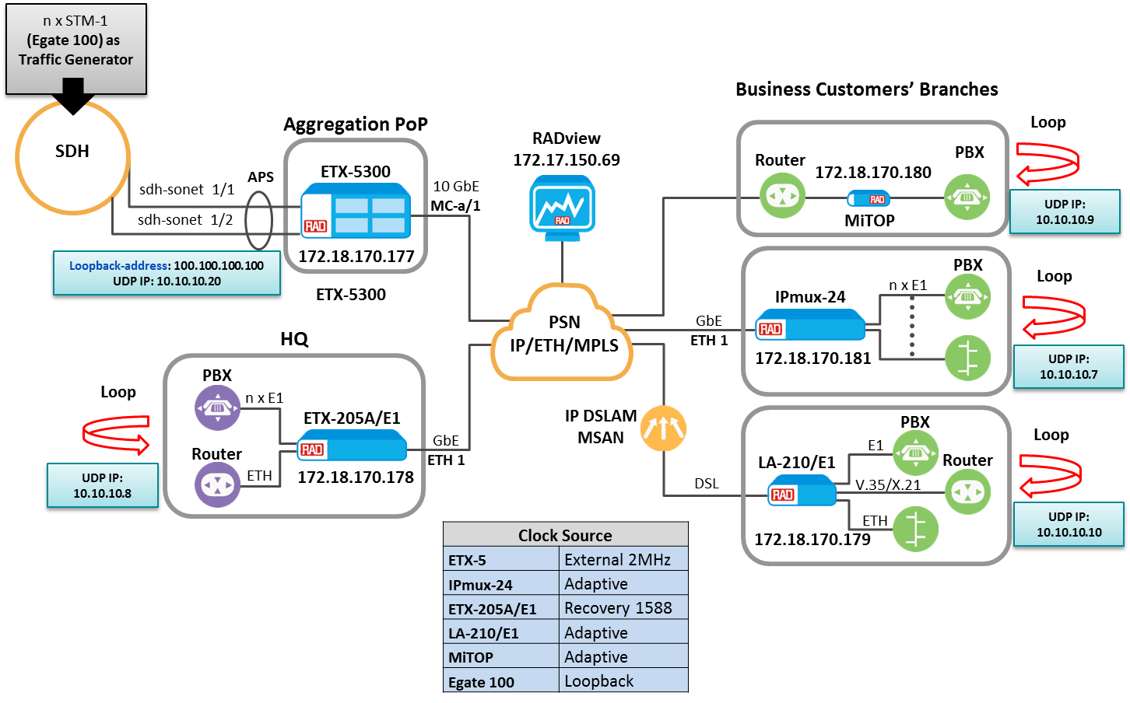

### Test Case 1: PW1-4 between Aggregation POP to IPmux-24

**Service Provisioning**

1. Configure **ETX-5 Services PW1-PW4** according to scripts in Appendix D.1
2. Configure **IPMUX-24 Services PW1-PW4** according to scripts in Appendix D.1
3. Connect STM1-TTC to TDM port 1 on the ETX-5 MS
4. Connect E1 TDM Loop to each of the TDM port in the IPMUX-24
5. Verify the service was successfully created.

##### Test Procedure

|  |  |  |  |
| --- | --- | --- | --- |
| Basic TDM traffic testing | | | |
| # | Action | Expected Result | Pass/Fail |
|  | Set the TTC generator to transmit E1 2*10^11 pattern on each of the tributary (see table) and test no bit error occurs | No bit error occurs  No frame slip | **pass** |
|  | Check PM screens in ETX-5 and IPMUX-24 | No ES were counted | **pass** |
|  | Inject a few bits error (i.e. TSE) | A few bits error were counted | **Pass** |
|  | Check PM screens in ETX-5 and IPMUX-24 | A few ES were counted | **pass** |

###### 

|  |  |  |  |  |
| --- | --- | --- | --- | --- |
| **Tributary under test** | | | | |
| **#** | **Service** | **Tributary** | | |
|  | **TUG3** | **TUG2** | **TU** |
|  | **PW 1** | **1** | **1** | **1** |
|  | **PW 2** | **2** | **1** | **1** |
|  | **PW 3** | **3** | **1** | **1** |
|  | **PW 4** | **1** | **2** | **1** |

###### Protection testing

1. Connect E1-TTC to IPMUX-24 TDM port with Protection time measurement feature.
2. Connect STM1 TDM Loop to each of the TDM port in the ETX-5 MS

|  |  |  |  |
| --- | --- | --- | --- |
| Basic TDM traffic testing | | | |
| # | Action | Expected Result | Pass/Fail |
|  | Disconnect STM port 1 and connect | Few bits error, TTC >50mSec | **pass** |
|  | Check Status screens in ETX-5 | Port 2 is active Port 1 Standby | **pass** |
|  | Disconnect STM port 2 and connect | Few bits error, TTC >50mSec | **Pass** |
|  | Check Status screens in ETX-5 | Port 1 is active Port 2 Standby | **pass** |

***Note****: Perform each test per TDM port of IPmux-24*

### Test Case 2: PW5-8 between Aggregation POP to HQ, ETX-205

**Service Provisioning**

1. Configure **ETX-5 Services PW5-PW8** according to scripts in Appendix D.2
2. Configure **ETX-205 Services PW5-PW8** according to scripts in Appendix D.2
3. Configure **ETX-5 Master configuration** according to script Appendix C.1
4. Configure **ETX-205 Slave configuration** according to script Appendix C.2
5. Connect STM1-TTC to TDM port 1 on the ETX-5 MS
6. Connect E1 TDM Loop to each of the TDM port in the ETX-205
7. Verify the service was successfully created.

##### Test Procedure

|  |  |  |  |
| --- | --- | --- | --- |
| Basic TDM traffic testing | | | |
| # | Action | Expected Result | Pass/Fail |
|  | Set the TTC generator to transmit E1 2*10^11 pattern on each of the tributary (see table) and test no bit error occurs | No bit error occurs  No frame slip | **pass** |
|  | Check PM screens in ETX-5 and ETX-205 | No ES were counted | **pass** |
|  | Inject a few bits error (i.e. TSE) | A few bits error were counted | **Pass** |
|  | Check PM screens in ETX-5 and ETX-205 | A few ES were counted | **pass** |

|  |  |  |  |  |
| --- | --- | --- | --- | --- |
| **Tributary under test** | | | | |
| **#** | **Service** | **Tributary** | | |
|  | **TUG3** | **TUG2** | **TU** |
|  | **PW 5** | **2** | **2** | **1** |
|  | **PW 6** | **3** | **2** | **1** |
|  | **PW 7** | **1** | **3** | **1** |
|  | **PW 8** | **2** | **3** | **1** |

###### Protection testing

1. Connect E1-TTC to ETX-205 TDM port with Protection time measurement feature.
2. Connect STM1 TDM Loop to each of the TDM port in the ETX-5 MS

|  |  |  |  |
| --- | --- | --- | --- |
| Basic TDM traffic testing | | | |
| # | Action | Expected Result | Pass/Fail |
|  | Disconnect STM port 1 and connect | Few bits error, TTC >50mSec | **pass** |
|  | Check Status screens in ETX-5 | Port 2 is active Port 1 Standby | **pass** |
|  | Disconnect STM port 2 and connect | Few bits error, TTC >50mSec | **Pass** |
|  | Check Status screens in ETX-5 | Port 1 is active Port 2 Standby | **pass** |

***Note****: Perform each test per TDM port of ETX-205*

### Test Case 3: PW9 between Aggregation POP and MiTOP(E1)

**Service Provisioning**

1. Configure **ETX-5 Services PW9** according to scripts in Appendix D.3
2. Configure **MiTOP Services PW9** according to scripts in Appendix D.3
3. Connect STM1-TTC to TDM port 1 on the ETX-5 MS
4. Connect E1 TDM Loop to the TDM port in the MiTOP
5. Verify the service was successfully created.

##### Test Procedure

|  |  |  |  |
| --- | --- | --- | --- |
| Basic TDM traffic testing | | | |
| # | Action | Expected Result | Pass/Fail |
|  | Set the TTC generator to transmit E1 2*10^11 pattern on each of the tributary (see table) and test no bit error occurs | No bit error occurs  No frame slip | **pass** |
|  | Check PM screens in ETX-5 and MiTOP | No ES were counted | **pass** |
|  | Inject a few bits error (i.e. TSE) | A few bits error were counted | **Pass** |
|  | Check PM screens in ETX-5 and MiTOP | A few ES were counted | **pass** |

|  |  |  |  |  |
| --- | --- | --- | --- | --- |
| **Tributary under test** | | | | |
| **#** | **Service** | **Tributary** | | |
|  | **TUG3** | **TUG2** | **TU** |
|  | **PW 9** | **3** | **3** | **1** |

###### Protection testing

1. Connect E1-TTC to MiTOP TDM port with Protection time measurement feature.
2. Connect STM1 TDM Loop to each of the TDM port in the ETX-5 MS

|  |  |  |  |
| --- | --- | --- | --- |
| Basic TDM traffic testing | | | |
| # | Action | Expected Result | Pass/Fail |
|  | Disconnect STM port 1 and connect | Few bits error, TTC >50mSec | **pass** |
|  | Check Status screens in ETX-5 | Port 2 is active Port 1 Standby | **pass** |
|  | Disconnect STM port 2 and connect | Few bits error, TTC >50mSec | **Pass** |
|  | Check Status screens in ETX-5 | Port 1 is active Port 2 Standby | **pass** |

### Test Case 4: PW10 between Aggregation POP to LA-210

**Service Provisioning**

1. Configure **ETX-5 Services PW10** according to scripts in Appendix D.4
2. Configure **LA-210 Services PW10** according to scripts in Appendix D.4
3. Connect STM1-TTC to TDM port 1 on the ETX-5 MS
4. Connect E1 TDM Loop to the TDM port in the LA-210
5. Verify the service was successfully created.

##### Test Procedure

|  |  |  |  |
| --- | --- | --- | --- |
| Basic TDM traffic testing | | | |
| # | Action | Expected Result | Pass/Fail |
|  | Set the TTC generator to transmit E1 2*10^11 pattern on each of the tributary (see table) and test no bit error occurs | No bit error occurs  No frame slip | **pass** |
|  | Check PM screens in ETX-5 and LA-210 | No ES were counted | **pass** |
|  | Inject a few bits error (i.e. TSE) | A few bits error were counted | **Pass** |
|  | Check PM screens in ETX-5 and LA-210 | A few ES were counted | **pass** |

|  |  |  |  |  |
| --- | --- | --- | --- | --- |
| **Tributary under test** | | | | |
| **#** | **Service** | **Tributary** | | |
|  | **TUG3** | **TUG2** | **TU** |
|  | **PW 10** | **1** | **4** | **1** |

###### Protection testing

1. Connect E1-TTC to LA-210 TDM port with Protection time measurement feature.
2. Connect STM1 TDM Loop to each of the TDM port in the ETX-5 MS

|  |  |  |  |
| --- | --- | --- | --- |
| Basic TDM traffic testing | | | |
| # | Action | Expected Result | Pass/Fail |
|  | Disconnect STM port 1 and connect | Few bits error, TTC >50mSec | **pass** |
|  | Check Status screens in ETX-5 | Port 2 is active Port 1 Standby | **pass** |
|  | Disconnect STM port 2 and connect | Few bits error, TTC >50mSec | **Pass** |
|  | Check Status screens in ETX-5 | Port 1 is active Port 2 Standby | **pass** |

## TDM Services OC-3 – SAToP, MEF8 between Edge Endpoints

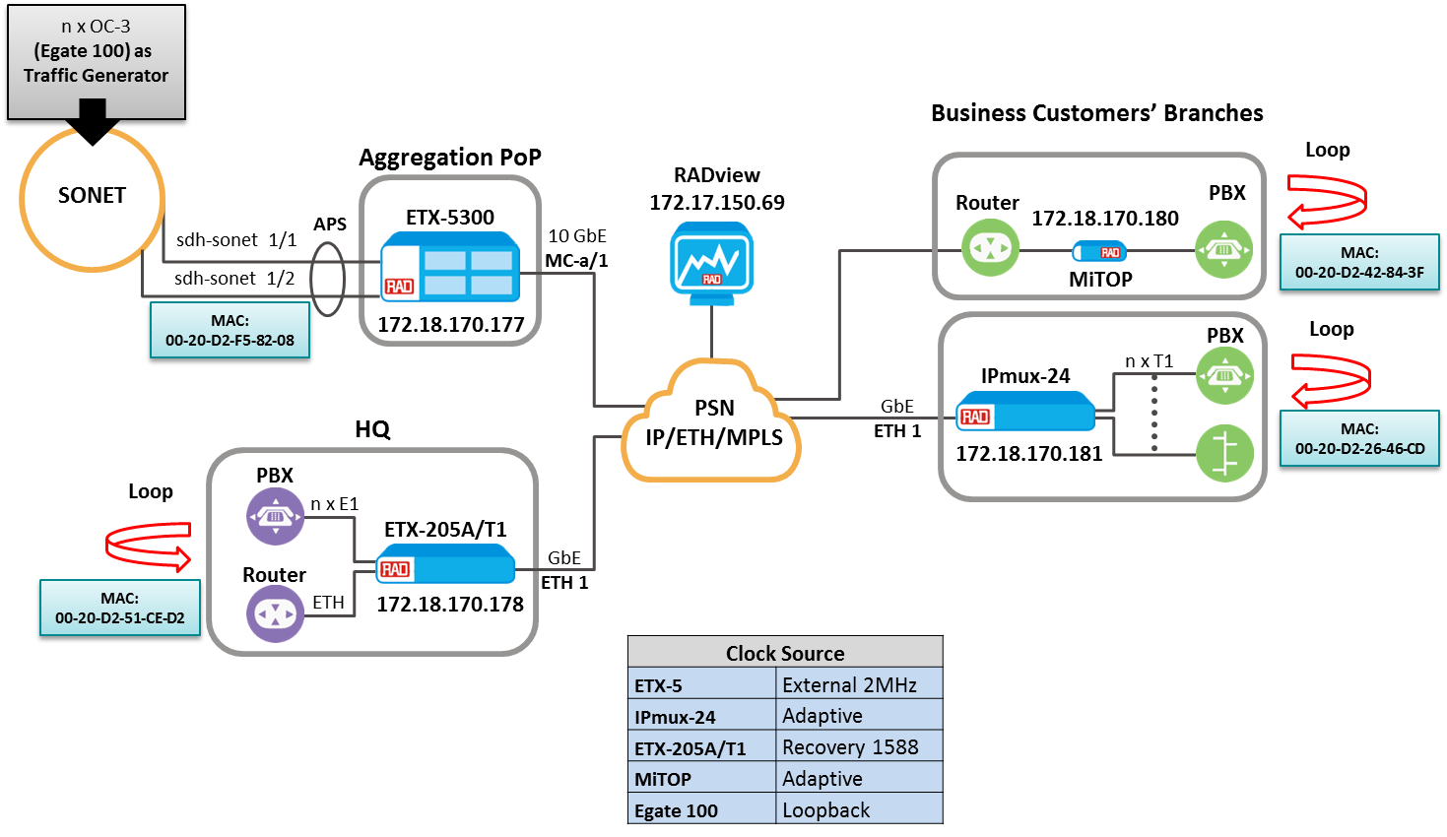

### Test Case 1: PW1-4 between Aggregation POP to IPmux-24

**Service Provisioning**

1. Configure **ETX-5 Services PW1-PW4** according to scripts in Appendix E.1
2. Configure **IPMUX-24 Services PW1-PW4** according to scripts in Appendix E.1
3. Connect OC3-TTC to TDM port 1 on the ETX-5 MS
4. Connect T1 TDM Loop to each of the TDM port in the IPMUX-24
5. Verify the service was successfully created.

##### Test Procedure

|  |  |  |  |
| --- | --- | --- | --- |
| Basic TDM traffic testing | | | |
| # | Action | Expected Result | Pass/Fail |
|  | Set the TTC generator to transmit T1 2*10^11 pattern on each of the tributary (see table) and test no bit error occurs | No bit error occurs  No frame slip | **pass** |
|  | Check PM screens in ETX-5 and IPMUX-24 | No ES were counted | **pass** |
|  | Inject a few bits error (i.e. TSE) | A few bits error were counted | **Pass** |
|  | Check PM screens in ETX-5 and IPMUX-24 | A few ES were counted | **pass** |

|  |  |  |  |  |
| --- | --- | --- | --- | --- |
| **Tributary under test** | | | | |
| **#** | **Service** | **Tributary** | | |
|  | **TUG3** | **TUG2** | **TU** |
|  | **PW 1** | **1** | **1** | **1** |
|  | **PW 2** | **2** | **1** | **1** |
|  | **PW 3** | **3** | **1** | **1** |
|  | **PW 4** | **1** | **2** | **1** |

###### Protection testing

1. Connect T1-TTC to IPMUX-24 TDM port with Protection time measurement feature.
2. Connect OC3 TDM Loop to each of the TDM port in the ETX-5 MS

|  |  |  |  |
| --- | --- | --- | --- |
| Basic TDM traffic testing | | | |
| # | Action | Expected Result | Pass/Fail |
|  | Disconnect OC3 port 1 and connect | Few bits error, TTC >50mSec | **pass** |
|  | Check Status screens in ETX-5 | Port 2 is active Port 1 Standby | **pass** |
|  | Disconnect OC3 port 2 and connect | Few bits error, TTC >50mSec | **Pass** |
|  | Check Status screens in ETX-5 | Port 1 is active Port 2 Standby | **pass** |

***Note****: Perform each test per TDM port of IPmux-24*

### Test Case 2: PW5-8 between Aggregation POP to HQ, ETX-205

**Service Provisioning**

1. Configure **ETX-5 Services PW5-PW8** according to scripts in Appendix E.2
2. Configure **ETX-205 Services PW5-PW8** according to scripts in Appendix E.2
3. Configure **ETX-5 Master configuration** according to script C.1
4. Configure **ETX-205 Slave configuration** according to script C.2
5. Connect OC3-TTC to TDM port 1 on the ETX-5 MS
6. Connect T1 TDM Loop to each of the TDM port in the ETX-205
7. Verify the service was successfully created.

##### Test Procedure

|  |  |  |  |
| --- | --- | --- | --- |
| Basic TDM traffic testing | | | |
| # | Action | Expected Result | Pass/Fail |
|  | Set the TTC generator to transmit T1 2*10^11 pattern on each of the tributary (see table) and test no bit error occurs | No bit error occurs  No frame slip | **pass** |
|  | Check PM screens in ETX-5 and ETX-205 | No ES were counted | **pass** |
|  | Inject a few bits error (i.e. TSE) | A few bits error were counted | **Pass** |
|  | Check PM screens in ETX-5 and ETX-205 | A few ES were counted | **pass** |

|  |  |  |  |  |
| --- | --- | --- | --- | --- |
| **Tributary under test** | | | | |
| **#** | **Service** | **Tributary** | | |
|  | **TUG3** | **TUG2** | **TU** |
|  | **PW 5** | **2** | **2** | **1** |
|  | **PW 6** | **3** | **2** | **1** |
|  | **PW 7** | **1** | **3** | **1** |
|  | **PW 8** | **2** | **3** | **1** |

###### Protection testing

1. Connect T1-TTC to ETX-205 TDM port with Protection time measurement feature.
2. Connect OC3 TDM Loop to each of the TDM port in the ETX-5 MS

|  |  |  |  |
| --- | --- | --- | --- |
| Basic TDM traffic testing | | | |
| # | Action | Expected Result | Pass/Fail |
|  | Disconnect OC3 port 1 and connect | Few bits error, TTC >50mSec | **pass** |
|  | Check Status screens in ETX-5 | Port 2 is active Port 1 Standby | **pass** |
|  | Disconnect OC3 port 2 and connect | Few bits error, TTC >50mSec | **Pass** |
|  | Check Status screens in ETX-5 | Port 1 is active Port 2 Standby | **pass** |

***Note****: Perform each test per TDM port of ETX-205*

### Test Case 3: PW9 between Aggregation POP to MiTOP (T1)

**Service Provisioning**

1. Configure **ETX-5 Services PW9** according to scripts in Appendix E.3
2. Configure **MiTOP Services PW9** according to scripts in Appendix E.3
3. Connect OC3-TTC to TDM port 1 on the ETX-5 MS
4. Connect T1 TDM Loop to the TDM port in the MiTOP
5. Verify the service was successfully created.

##### Test Procedure

|  |  |  |  |
| --- | --- | --- | --- |
| Basic TDM traffic testing | | | |
| # | Action | Expected Result | Pass/Fail |
|  | Set the TTC generator to transmit T1 2*10^11 pattern on each of the tributary (see table) and test no bit error occurs | No bit error occurs  No frame slip | **pass** |
|  | Check PM screens in ETX-5 and MiTOP | No ES were counted | **pass** |
|  | Inject a few bits error (i.e. TSE) | A few bits error were counted | **Pass** |
|  | Check PM screens in ETX-5 and MiTOP | A few ES were counted | **pass** |

|  |  |  |  |  |
| --- | --- | --- | --- | --- |
| **Tributary under test** | | | | |
| **#** | **Service** | **Tributary** | | |
|  | **TUG3** | **TUG2** | **TU** |
|  | **PW 9** | **3** | **3** | **1** |

###### Protection testing

1. Connect T1-TTC to MiTOP TDM port with Protection time measurement feature.
2. Connect OC3 TDM Loop to each of the TDM port in the ETX-5 MS

|  |  |  |  |
| --- | --- | --- | --- |
| Basic TDM traffic testing | | | |
| # | Action | Expected Result | Pass/Fail |
|  | Disconnect OC3 port 1 and connect | Few bits error, TTC >50mSec | **pass** |
|  | Check Status screens in ETX-5 | Port 2 is active Port 1 Standby | **pass** |
|  | Disconnect OC3 port 2 and connect | Few bits error, TTC >50mSec | **Pass** |
|  | Check Status screens in ETX-5 | Port 1 is active Port 2 Standby | **pass** |

1. Appendix A – STM1
   1. Aggregation POP – ETX-5 Preliminary Setting

##### Factory default

|  |
| --- |
| admin factory-default |

##### Hardware, Queues and Port Configuration

|  |
| --- |
| #HW Configuration  #config slot 1 card-type sdh-sonet stm-1-ch-4  #config slot 1 no shutdown  #*when IO card ready run script  #***************************Classification_Key***************************  config port ethernet main-a/1 classification-key vlan p-bit  exit all  #***************************MC_QUEUE_GROUP*******************************  configure qos queue-group-profile q_group_3_level_default_MC_a/1  inherited-from q_group_3_level_default  exit all  #***************************BIND_QG_TO_PORTS*******************************  config port ethernet main-a/1 queue-group profile q_group_3_level_default_MC_a/1  exit all  #***************************Color-Mapping*******************************  config qos color-map-profile dei-color-map classification dei  exit all  #******************************PORT_ACTIVATION**************************  config port ethernet main-a/1 no shutdown  exit all  #***************************END*******************************  #**********************END_OF_SCRIPT**************************  #***************************END******************************* |

##### Local Management Set Up configuration

|  |
| --- |
| #***************************SNMP Configuration***************************  configure system name "Aggregation_POP"  exit all  config management  snmp  target-params "PC_69"  message-processing-model snmpv3  version usm  security name "initial" level no-auth-no-priv  no shutdown  exit  target "a"  target-params "PC_69"  address udp-domain 172.17.150.69  no shutdown  tag-list "unmasked"  trap-sync-group 1  exit  config-change-notification  exit all  #******************************configure port svi**************************  exit all  configure port svi 99 router  exit all  #*****************************End port svi Configuration******************  #***************************Marking-Mapping*******************************  config qos marking-profile "mark1" color-aware green-yellow dei mapping  mark 0..7 green to 0 dei green  mark 0..7 yellow to 0 dei yellow  exit all  #***************************End Marking-Mapping******************************  #**************** Classifier Profile Configuration **********************  config flows classifier-profile "all" match-any match all  config flows classifier-profile "VLAN_4094" match-any match vlan 4094  exit all  #*************** End Classifier Profile Configuration **********************  #************************Flows_Inband_Configuration*************************  config flows flow "mng_in_router"  classifier "VLAN_4094"  ingress-port ethernet main-a/1  egress-port svi 99  vlan-tag pop vlan  no shutdown  exit all  config flows flow "mng_out_router"  classifier "all"  ingress-port svi 99  egress-port ethernet main-a/1 queue-map-profile "QueueMapDefaultProfile" block 0/1  vlan-tag push vlan 4094 p-bit profile "mark1" tag-ether-type 0x8100  no shutdown  exit all  #*********************End Flows_Inband_Configuration*******************************  #*************************Router _Configuration************************************  config router 1  name "Router#1"  interface 1  address 172.18.170.177/24  bind svi 99  no shutdown  exit  static-route 0.0.0.0/0 address 172.18.170.1  exit all  #********************* End Router _Configuration ******************************* |
|  |

##### Configure STM1 (High Level) and Protection

|  |
| --- |
| # ********************Define IO card******************  #config slot 1 card-type sdh-sonet stm-1-ch-4  #config slot 1 no shutdown  #*****************************************************  # ********************External 2Mhz clock*************  config system clock station main-a/1  interface-type 2mhz  no shutdown  exit all  config system clock domain 1 source 1 station main-a/1  quality-level prs  wait-to-restore 0  clear-wait-to-restore  exit all  # ***************************************************  # *********************** APS ***********************  # ***************************************************  configure protection aps 1_1and1_2  bind working sdh-sonet 1/1  bind protection sdh-sonet 1/2  no shutdown  exit all  # ***************************************************  # ***************** Physical Ports ******************  # ***************************************************  # ***************************************************  # ********************** SDH **********************  # ***************************************************  config port sdh-sonet 1/1  frame-type sdh  no tim-action soh path vt  tx-clock-source domain 1  no shutdown  exit all  config port sdh-sonet 1/2  frame-type sdh  no tim-action soh path vt  tx-clock-source domain 1  no shutdown  exit all  # ***************************************************  # *********************** AUG ***********************  # ***************************************************  configure port sdh-sonet 1/1 aug 1 no shutdown  configure port sdh-sonet 1/2 aug 1 no shutdown |

* 1. HQ – ETX-205 Preliminary Setting

##### Factory default

|  |
| --- |
| admin factory-default |

##### Queues Configuration

|  |
| --- |
| #************************ETX-203AX,ETX-205A***************************  #***************************QUEUE_GROUP*******************************  exit all  config qos queue-group-profile QGN1  exit all  config port eth 1 queue-group profile QGN1  exit all  config qos queue-group-profile QGN2  exit all  config port eth 2 queue-group profile QGN2  exit all  config qos queue-group-profile QGN3  exit all  config port eth 3 queue-group profile QGN3  exit all  config qos queue-group-profile QGN4  exit all  config port eth 4 queue-group profile QGN4  exit all  config qos queue-group-profile QGN5  exit all  config port eth 5 queue-group profile QGN5  exit all  config qos queue-group-profile QGN6  exit all  config port eth 6 queue-group profile QGN6  exit all  save  #***************************END*******************************  #**********************END_OF_SCRIPT**************************  #***************************END******************************* |

##### Local Management Set Up configuration

|  |
| --- |
| #***************************SNMP Configuration************************  configure system name "HQ"  exit all  config management  snmp  target-params "PC_69"  message-processing-model snmpv3  version usm  security name "initial" level no-auth-no-priv  no shutdown  exit  target "a"  target-params "PC_69"  address udp-domain 172.17.150.69  no shutdown  tag-list "unmasked"  trap-sync-group 1  exit  config-change-notification  exit all  #************************* END SNMP Configuration ***********************  #*************************** Inband MNG ***********************  config port svi 1  no shutdown  exit all  config flows classifier-profile "all" match-any match all  config flows classifier-profile "VLAN_4094" match-any match vlan 4094  config flows flow "Eth_1_svi_1"  classifier "VLAN_4094"  no policer  vlan-tag pop vlan  ingress-port ethernet 1  egress-port svi 1 queue 0  no shutdown  exit all  config flows flow "svi_1_Eth_1"  classifier "all"  no policer  ingress-port svi 1  egress-port ethernet 1 queue 0 block 0/1  vlan-tag push vlan 4094 p-bit fixed 0  no shutdown  exit all  config router 1  name "Router#1"  interface 1  address 172.18.170.178/24  bind svi 1  no shutdown  exit  static-route 0.0.0.0/0 address 172.18.170.1  exit all  #*************************** END Inband MNG ************************** |

* 1. IPmux-24 – Management, TDM type and Mux Method Setting

Menu driven. Baud rate 115,200 bps.

##### Factory Default

1. Root->Configuration

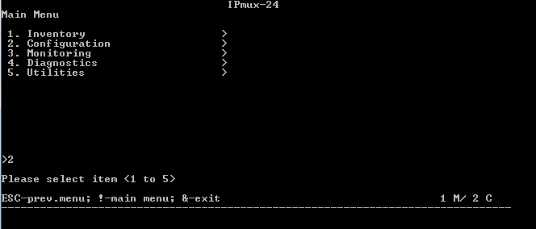

1. Configuration->System

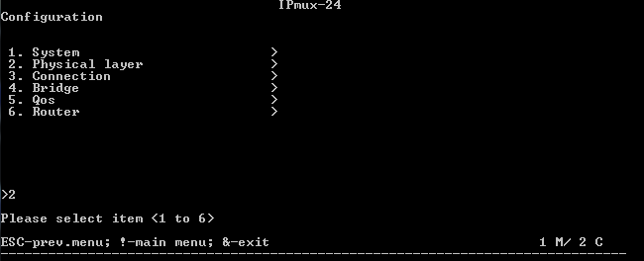

1. System->Factory Default

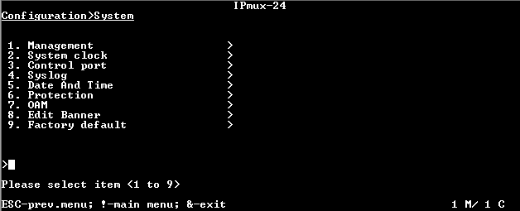

##### TDM Type Setting

1. Change the IPMUX 5 TDM port type to E1:
2. Root->Configuration



1. Configuration->Physical Layer



1. TDM interface type – change to E1, press ‘s’, device will restart.

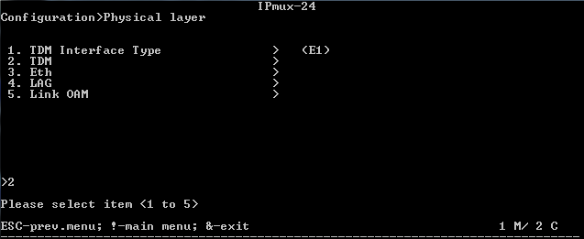

***Note****: configuration will take action after rebooting.*

##### Mux method setting

Before creating any bundle

1. Root->Configuration



1. Configuration->Connection

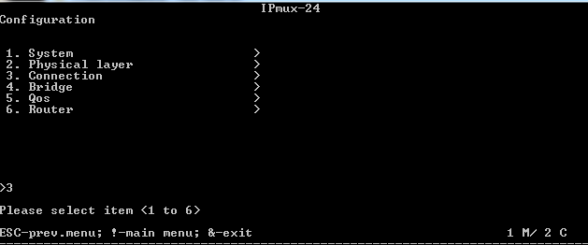

1. Multiplexing->select item 3 followed by a reset to Destination Port

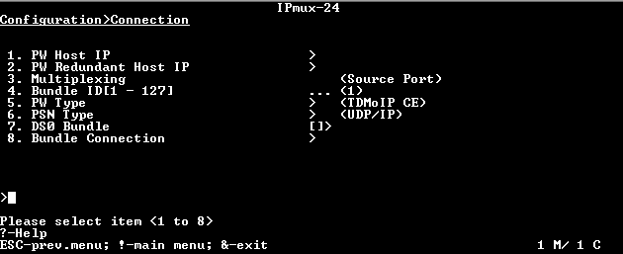

***Note****: configuration will take action after rebooting.*

##### Management Configuration

1. Root->Configuration

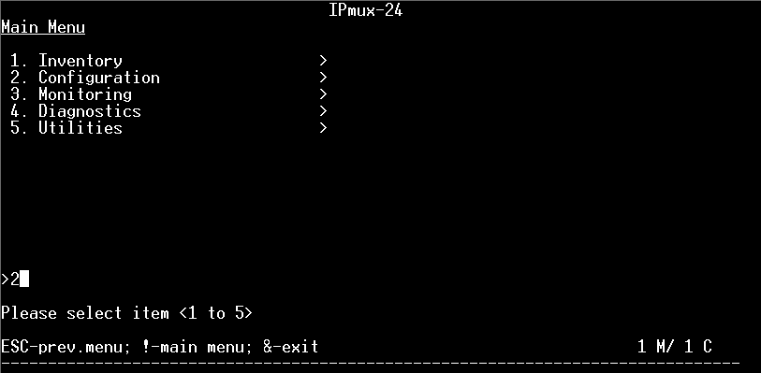

1. Configuration->System

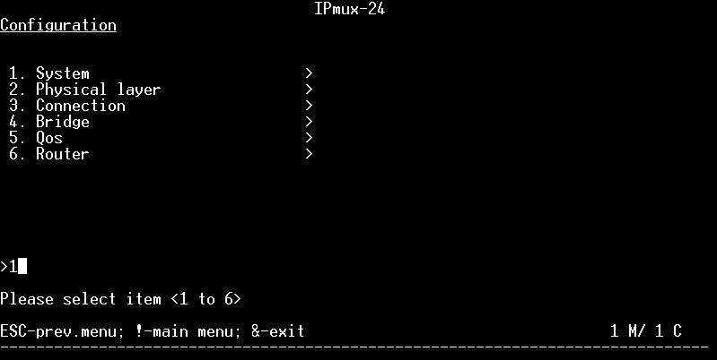

1. System->Management

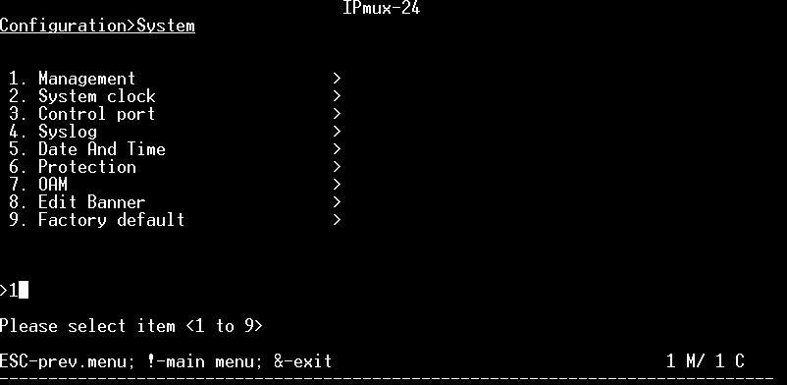

1. Management->Host IP

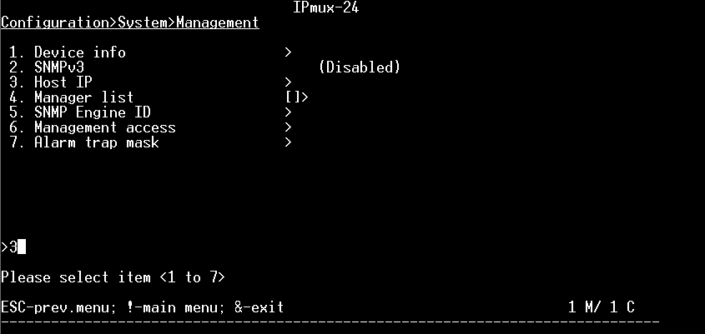

1. DHCP Status, change to Disable and press ‘s’ to save.

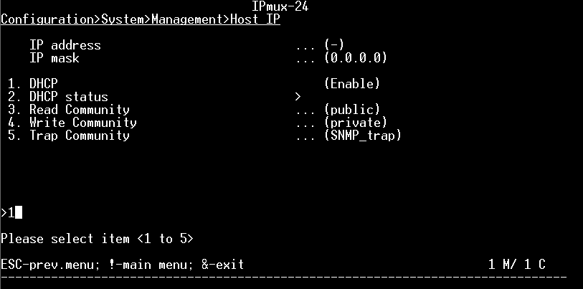

1. Configure IP Address and Subnet Mask and press ‘s’ to save.

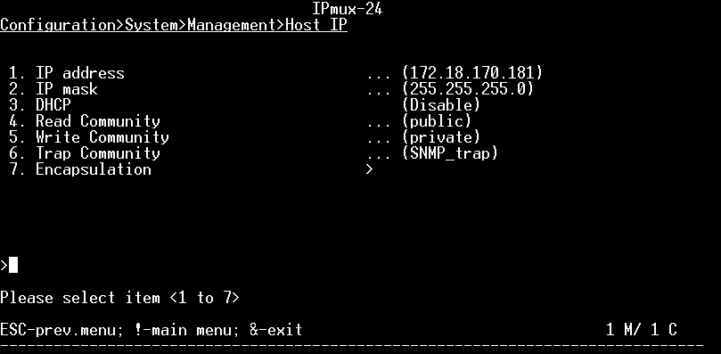

1. Configure Encapsulation VLAN 4094 for management (pBit 0) and ‘s’ to save.

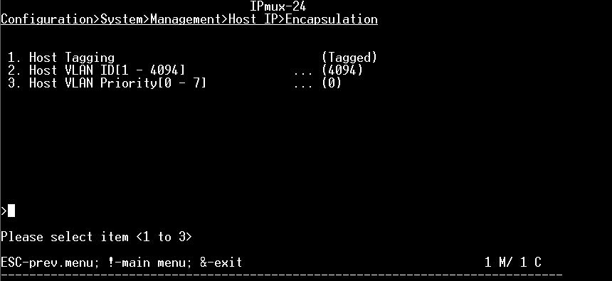

1. Press ESC to return to Configuration screen.
2. Configuration->Router

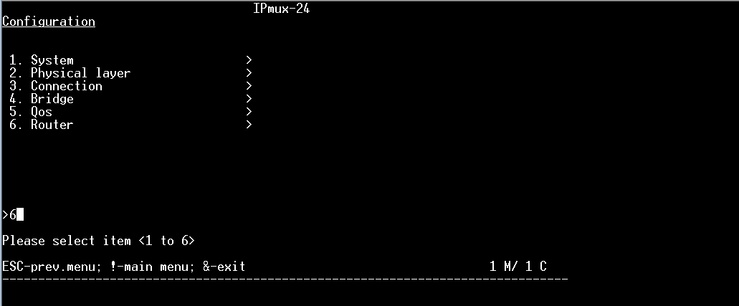

1. Define Gate Way, and press ‘s’ to save.

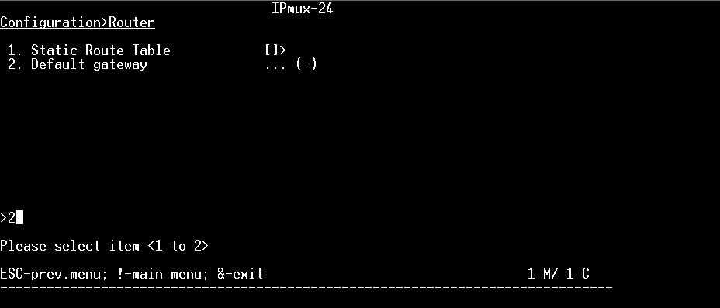

1. Press ESC to back to Configuration Screen.
2. Configuration->Bridge

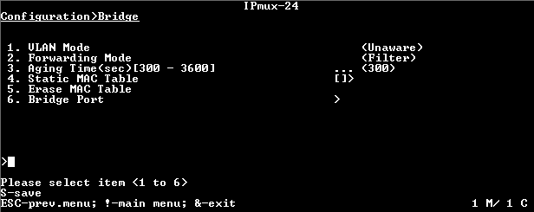

1. Change the VLAN mode to Aware, to support VLAN.
2. And add VLAN membership

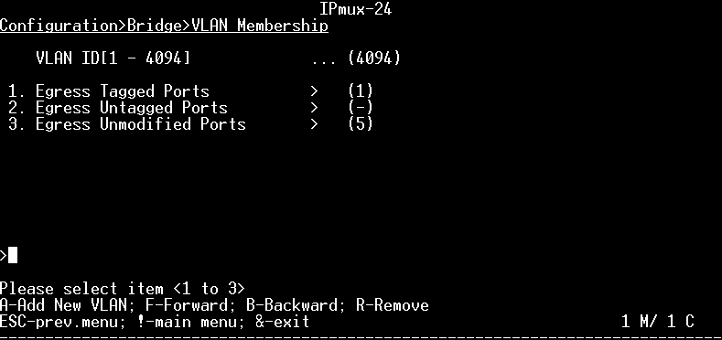

1. Press A to add VLAN 4094, press ‘s’ to save.
   1. LA-210 – Preliminary Setting

##### Factory default

|  |
| --- |
| admin factory-default |

##### Management Configuration

|  |
| --- |
| configure  # System Configuration  system name "LA-210_TDM"  exit  # Port Configuration  port    # Service Virtual Interface- Port Configuration  svi 1 name "SVI-1 " exit  e1 1  name "E1-1"  tx-clock-source adaptive  line-type g732n  exit  exit    # Bridge Configuration  bridge 1 vlan-aware filtering  port 1  pvid 4094 priority 0  exit  # VLAN Configuration  vlan 401  tagged-egress 6,1  exit    # VLAN Configuration  vlan 4094  tagged-egress 6  untagged-egress 1  exit  exit  router 1 interface 1 address 172.18.170.182/24 no shutdown exit  interface 2  address 10.10.10.10/24  vlan 401 priority 7  name "Interface-2"  no shutdown  exit  default-gateway address 172.18.170.1 exit    management snmp snmpv3  security-to-group usm sec-name "initial" group-name "initial" no shutdown exit  target-params "PC_69" message-processing-model snmpv3 version usm security name "initial" level no-auth-no-priv no shutdown exit  target "a" target-params "PC_69" address udp-domain 172.17.150.69 no shutdown tag-list "unmasked" exit all    save |

* 1. MiTOP – Preliminary Setting

##### MiTOP Dip Switch Roll

##### 

##### Configuration Adapter

|  |  |
| --- | --- |
| An optional configuration adapter (SFP-CA) is available for connecting MiTOP-E1/T1 to a PC via a USB 2.0 port.  The configuration adapter is used for preliminary configuration or software download.  Or use a standard L2/L3 switch with SFP sleeve |  |

.

##### Factory Default

1. Remove MiTOP from sleeve.
2. Set DIP switch SW1 and SW2 OFF.
3. Plug MiTOP to sleeve (make sure Power is ON).
4. Wait 30 seconds.
5. Remove MiTOP and set Dip Switch to Normal according table above.
6. Default management IP address: 192.168.205.1 TDM Frame Type: E1
7. Use *Microsoft Explorer* or *Google Chrome* and navigate to [*http://192.168.205.1*](http://192.168.205.1)

##### Configuring the Host IP Parameters

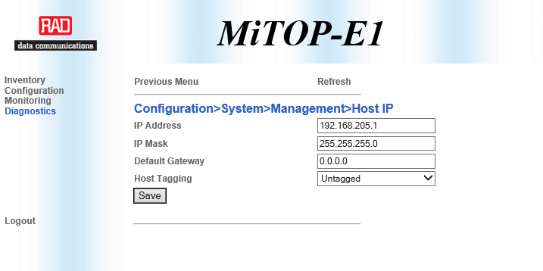

1. Configure the host IP parameters (Configuration > System > Management > Host IP):

* Disable DHCP client
* Set the IP Address field: 172.18.170.180
* Set the IP Mask field: 255.255.255.0
* Set the Default Gateway field: IP address.
* Set Host tagging to be Tagged Host VLAN ID: 4094
* Host VLAN Priority: 0

1. Appendix B – SONET (OC-3)

##### *Note: Network Elements are TDM port type E1 based, and needed to modify to T1 type*.

* 1. Aggregation POP – ETX-5 Preliminary Setting

##### Factory default

|  |
| --- |
| admin factory-default |

##### Hardware, Queues and Port Configuration

|  |
| --- |
| #HW Configuration  #config slot 1 card-type sdh-sonet oc-3-ch-4  #config slot 1 no shutdown  #*when IO card ready run script  #***************************Classification_Key***************************  config port ethernet main-a/1 classification-key vlan p-bit  exit all  #***************************MC_QUEUE_GROUP*******************************  configure qos queue-group-profile q_group_3_level_default_MC_a/1  inherited-from q_group_3_level_default  exit all  #***************************BIND_QG_TO_PORTS*******************************  config port ethernet main-a/1 queue-group profile q_group_3_level_default_MC_a/1  exit all  #***************************Color-Mapping*******************************  config qos color-map-profile dei-color-map classification dei  exit all  #******************************PORT_ACTIVATION**************************  config port ethernet main-a/1 no shutdown  exit all  #***************************END*******************************  #**********************END_OF_SCRIPT**************************  #***************************END******************************* |

##### Local Management Set Up configuration

|  |
| --- |
| #***************************SNMP Configuration***************************  configure system name "Aggregation_POP"  exit all  config management  snmp  target-params "PC_69"  message-processing-model snmpv3  version usm  security name "initial" level no-auth-no-priv  no shutdown  exit  target "a"  target-params "PC_69"  address udp-domain 172.17.150.69  no shutdown  tag-list "unmasked"  trap-sync-group 1  exit  config-change-notification  exit all  #******************************configure port svi**************************  exit all  configure port svi 99 router  exit all  #*****************************End port svi Configuration******************  #***************************Marking-Mapping*******************************  config qos marking-profile "mark1" color-aware green-yellow dei mapping  mark 0..7 green to 0 dei green  mark 0..7 yellow to 0 dei yellow  exit all  #***************************End Marking-Mapping******************************  #**************** Classifier Profile Configuration **********************  config flows classifier-profile "all" match-any match all  config flows classifier-profile "VLAN_4094" match-any match vlan 4094  exit all  #*************** End Classifier Profile Configuration **********************  #************************Flows_Inband_Configuration*************************  config flows flow "mng_in_router"  classifier "VLAN_4094"  ingress-port ethernet main-a/1  egress-port svi 99  vlan-tag pop vlan  no shutdown  exit all  config flows flow "mng_out_router"  classifier "all"  ingress-port svi 99  egress-port ethernet main-a/1 queue-map-profile "QueueMapDefaultProfile" block 0/1  vlan-tag push vlan 4094 p-bit profile "mark1" tag-ether-type 0x8100  no shutdown  exit all  #*********************End Flows_Inband_Configuration*******************************  #*************************Router _Configuration************************************  config router 1  name "Router#1"  interface 1  address 172.18.170.177/24  bind svi 99  no shutdown  exit  static-route 0.0.0.0/0 address 172.18.170.1  exit all  #********************* End Router _Configuration ******************************* |
|  |

##### Configure SONET (High Level) and Protection

|  |
| --- |
| # ********************Define IO card******************  #config slot 1 card-type sdh-sonet oc-3-ch-4  #config slot 1 no shutdown  #*****************************************************  # ********************External 2Mhz clock*************  config system clock station main-a/1  interface-type 2mhz  no shutdown  exit all  config system clock domain 1 source 1 station main-a/1  quality-level prs  wait-to-restore 0  clear-wait-to-restore  exit all  # ***************************************************  # *********************** APS ***********************  # ***************************************************  configure protection aps 1_1and1_2  bind working sdh-sonet 1/1  bind protection sdh-sonet 1/2  no shutdown  exit all  # ***************************************************  # ***************** Physical Ports ******************  # ***************************************************  # ***************************************************  # ********************** SONET **********************  # ***************************************************  config port sdh-sonet 1/1  no tim-action soh path vt  tx-clock-source domain 1  no shutdown  exit all  config port sdh-sonet 1/2  no tim-action soh path vt  tx-clock-source domain 1  no shutdown  exit all  # ***************************************************  # *********************** HVC ***********************  # ***************************************************  configure port sdh-sonet 1/1 oc3 1 sts1 1 no shutdown  configure port sdh-sonet 1/1 oc3 1 sts1 2 no shutdown  configure port sdh-sonet 1/1 oc3 1 sts1 3 no shutdown  configure port sdh-sonet 1/2 oc3 1 sts1 1 no shutdown  configure port sdh-sonet 1/2 oc3 1 sts1 2 no shutdown  configure port sdh-sonet 1/2 oc3 1 sts1 3 no shutdown |

##### MAC Address

PWE address is published under IO SDH-SONET, change scripts to support MAC

|  |
| --- |
| config port sdh-sonet 1/1 show status |

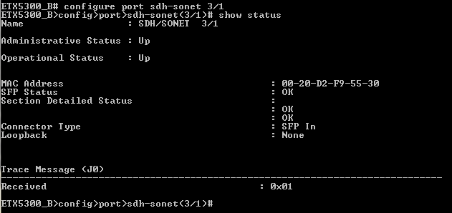

* 1. HQ - ETX-205 Preliminary Setting

##### Factory default

|  |
| --- |
| admin factory-default |

##### Queues Configuration

|  |
| --- |
| #************************ETX-203AX,ETX-205A***************************  #***************************QUEUE_GROUP*******************************  exit all  config qos queue-group-profile QGN1  exit all  config port eth 1 queue-group profile QGN1  exit all  config qos queue-group-profile QGN2  exit all  config port eth 2 queue-group profile QGN2  exit all  config qos queue-group-profile QGN3  exit all  config port eth 3 queue-group profile QGN3  exit all  config qos queue-group-profile QGN4  exit all  config port eth 4 queue-group profile QGN4  exit all  config qos queue-group-profile QGN5  exit all  config port eth 5 queue-group profile QGN5  exit all  config qos queue-group-profile QGN6  exit all  config port eth 6 queue-group profile QGN6  exit all  save  #***************************END*******************************  #**********************END_OF_SCRIPT**************************  #***************************END******************************* |

##### Local Management Set Up configuration

|  |
| --- |
| #***************************SNMP Configuration************************  configure system name "HQ"  exit all  config management  snmp  target-params "PC_69"  message-processing-model snmpv3  version usm  security name "initial" level no-auth-no-priv  no shutdown  exit  target "a"  target-params "PC_69"  address udp-domain 172.17.150.69  no shutdown  tag-list "unmasked"  trap-sync-group 1  exit  config-change-notification  exit all  #************************* END SNMP Configuration ***********************  #*************************** Inband MNG ***********************  config port svi 1  no shutdown  exit all  config flows classifier-profile "all" match-any match all  config flows classifier-profile "VLAN_4094" match-any match vlan 4094  config flows flow "Eth_1_svi_1"  classifier "VLAN_4094"  no policer  vlan-tag pop vlan  ingress-port ethernet 1  egress-port svi 1 queue 0  no shutdown  exit all  config flows flow "svi_1_Eth_1"  classifier "all"  no policer  ingress-port svi 1  egress-port ethernet 1 queue 0 block 0/1  vlan-tag push vlan 4094 p-bit fixed 0  no shutdown  exit all  config router 1  name "Router#1"  interface 1  address 172.18.170.178/24  bind svi 1  no shutdown  exit  static-route 0.0.0.0/0 address 172.18.170.1  exit all  #*************************** END Inband MNG ************************** |

##### MAC Address

1. PWE address is published under device-information, change scripts to support MAC

|  |
| --- |
| config system show device-information |

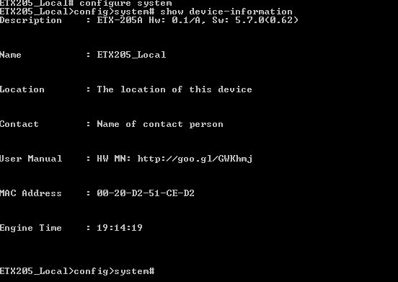

##### TDM Type Setting

|  |
| --- |
| #*************************** DS1 - Port Configuration ************************  config port ds1 1  frame-type t1  exit all  config port ds1 2  frame-type t1  exit all  config port ds1 3  frame-type t1  exit all  config port ds1 4  frame-type t1  exit all  #*************************** END DS1 - Port Configuration ********** |

* 1. IPMUX-24 – Management, TDM type and Mux Method Setting

Menu driven. Baud rate 115,200 bps.

##### Factory default

1. Root->Configuration



1. Configuration->System



1. System->Factory Default



##### TDM Type Setting

1. Change the IPMUX TDM port type to T1:
2. Root->Configuration



1. Configuration->Physical Layer



1. TDM interface type – change to T1, press ‘s’, device will restart.

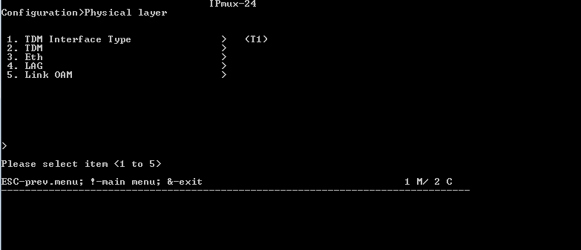

***Note****: configuration will take action after rebooting.*

##### Mux method setting

Before creating any bundle:

1. Root->Configuration



1. Configuration->Connection



1. Multiplexing->select item 3 followed by a reset to Destination Port



***Note****: configuration will take action after rebooting.*

##### Management Configuration

1. Root->Configuration



1. Configuration->System



1. System->Management



1. Management->Host IP



1. DHCP Status, change to Disable and press ‘s’ to save.



1. Configure IP Address and Subnet Mask and press ‘s’ to save.



1. Configure Encapsulation VLAN 4094 for management (pBit 0) and ‘s’ to save.



1. Press ESC to return to Configuration screen.
2. Configuration->Router



1. Define Gate Way, and press ‘s’ to save.



1. Press ESC to back to Configuration Screen.
2. Configuration->Bridge



1. Change the VLAN mode to Aware, to support VLAN.
2. And add VLAN membership



1. Press A to add VLAN 4094, press ‘s’ to save.

##### MAC Address

PWEa address is published under Inventory, change scripts to support MAC

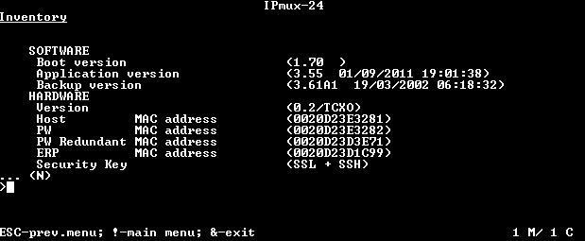

* 1. MiTOP – Preliminary Setting

##### MiTOP Dip Switch Roll

MiTOP-E1/T1 includes a 2-section DIP switch which is used for selecting one of the following operation modes of the device:

* Database initialization
* Normal operation
* Software download
* Configuration.

.

|  |  |
| --- | --- |
|  |  |

##### Configuration Adapter

|  |  |
| --- | --- |
| An optional configuration adapter (SFP-CA) is available for connecting MiTOP-E1/T1 to a PC via a USB 2.0 port.  The configuration adapter is used for preliminary configuration or software download.  Or use a standard L2/L3 switch with SFP sleeve |  |

.

##### Factory Default

1. Remove MiTOP from sleeve.
2. Set DIP switch SW1 and SW2 OFF.
3. Plug MiTOP to sleeve (make sure Power is ON).
4. Wait 30 seconds.
5. Remove MiTOP and set Dip Switch to Normal according table above.
6. Default management IP address: 192.168.205.1 TDM Frame Type: E1
7. Use Microsoft Explorer, Google Chrome or other and navigate to <http://192.168.205.1>

**Selecting the TDM Interface**

1. Select the TDM interface type from the Physical Ports menu (Configuration > Physical Ports).
2. Choose the type of the MiTOP-E1/T1 TDM link T1.

##### Configuring the Host IP Parameters

1. Configure the host IP parameters (Configuration > System > Management > Host IP):

* Disable DHCP client
* Set the IP Address field: 172.18.170.180
* Set the IP Mask field: 255.255.255.0
* Set the Default Gateway field: IP address.
* Set Host tagging to be Tagged Host VLAN ID: 4094
* Host VLAN Priority: 0

##### MAC Address

1. PWE address is published under Monitoring->system, change scripts to support MAC

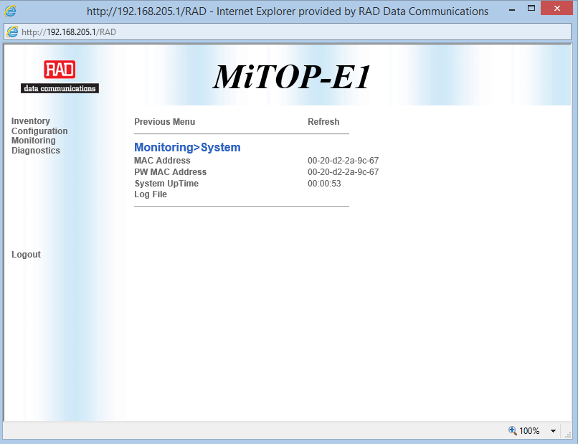

##### TDM Type Setting

1. Change the PW TDM type to T1
2. Root->Configuration

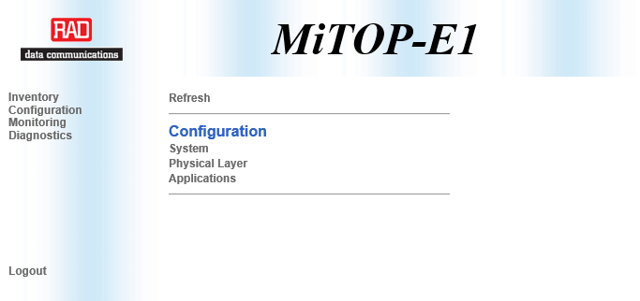

1. Physical Layer->Interface Type

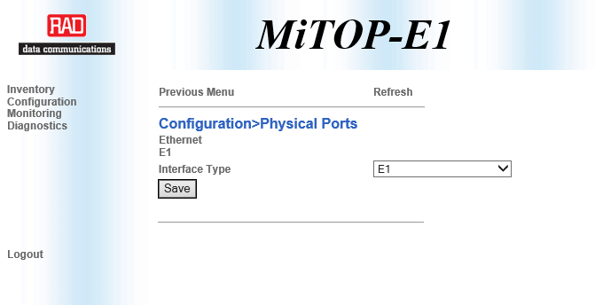

1. Select T1, and press ‘SAVE’ button

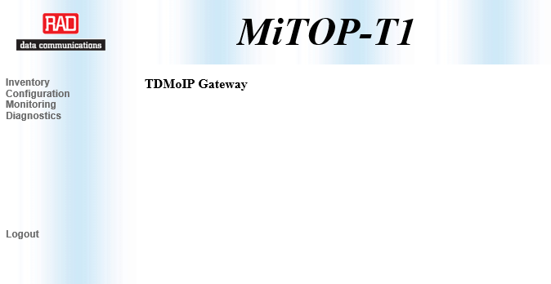

1. Appendix C – IEEE 1588v2 Frequency Synchronization (SDH and SONET)
   1. ETX-5 Master Configuration

|  |
| --- |
| #****************************** 1588-master_to_port ******************************  config port svi 202 router  exit all  config flows classifier-profile Vlan402 match-any  match vlan 402  exit all  config qos marking-profile "mark_1588" color-aware green-yellow dei mapping  mark 0..7 green to 2 dei green  mark 0..7 yellow to 2 dei yellow  exit all  #***************************** 1588 master main-a/1********************************  config flows flow 1588_m_main_a_1_svi_202  classifier Vlan402  ingress-port ethernet main-a/1  egress-port svi 202  vlan-tag pop vlan  no shutdown  exit all  config flows flow 1588_svi_202_main_a_1  classifier all  ingress-port svi 202  egress-port ethernet main-a/1 queue-map-profile QueueMapDefaultProfile block 0/2  vlan-tag push vlan 402 p-bit profile mark_1588  no shutdown  exit all  configure router 1 interface 4 loopback  #master ip ptp  address 30.30.30.30/32  no shutdown  exit all  configure router 1 interface 5  #master inter for int  address 50.50.50.2/24  bind svi 202  no shutdown  exit all  configure system clock master main-a/1 ptp  ip-address 30.30.30.30  sync-rate 128pps  #**********************************MASTER*as slave check check******************  no shutdown  exit all |

* 1. ETX-205 Slave Configuration

|  |
| --- |
| config port svi 3  no shutdown  exit all  config flows classifier-profile Vlan402 match-any  match vlan 402  exit all  config flows flow 1588_3_input  classifier "Vlan402"  ingress-port ethernet 1  egress-port svi 3  vlan-tag pop vlan  no shutdown  exit all  config flows flow 1588_3_out  classifier all  ingress-port svi 3  egress-port ethernet 1 queue 0 block 0/2  vlan-tag push vlan 402 p-bit fixed 2  no shutdown  exit all  #*****************************Router_Interface****************************  configure router 1  interface 3  address 50.50.50.3/24  bind svi 3  no management-access  no shutdown  exit  static-route 30.30.30.30/32 address 50.50.50.2  exit  peer 2 ip 30.30.30.30  exit all  #**************************** 1588_slave ******************************  configure system clock  domain 1  source 1 recovered 1  priority 1  quality-level ssm-based  wait-to-restore 0  clear-wait-to-restore  exit  exit  recovered 1 ptp  wait-to-restore 0  master 1  peer 2  priority 1  sync grant-period 300  announce grant-period 300  delay-respond grant-period 300  quality-level type1-ssm-based  no shutdown  exit  no shutdown  exit |

1. Appendix D – SDH – CESoPSN (UDP/IP) Services
   1. ETX-5 ↔ IPMUX-24 Services Configuration

##### ETX-5 Services PW1-PW4

|  |
| --- |
| # ***************************************************  # *********************** LVC ***********************  # ***************************************************  #----------------------------------------------------  # Port 1/1  #----------------------------------------------------  #*********************** STM-1 **************************  configure port sdh-sonet 1/1 aug 1 tug3 1 vc12 1 1 no shutdown  configure port sdh-sonet 1/1 aug 1 tug3 1 vc12 1 2 no shutdown  configure port sdh-sonet 1/1 aug 1 tug3 1 vc12 1 3 no shutdown  configure port sdh-sonet 1/1 aug 1 tug3 1 vc12 2 1 no shutdown  # *************************************************************  # *************************************************************  # ************************* E1 CONFIG *************************  # *************************************************************  config port e1 1/1/1 line-type g732n  config port e1 1/1/2 line-type g732n  config port e1 1/1/3 line-type g732n  config port e1 1/1/4 line-type g732n  #----------------------------------------------------  # E1 Clock Port 1/1_1/2  #----------------------------------------------------  configure port e1 1/1/1 tx-clock-source domain 1  configure port e1 1/1/2 tx-clock-source domain 1  configure port e1 1/1/3 tx-clock-source domain 1  configure port e1 1/1/4 tx-clock-source domain 1  #----------------------------------------------------  # SDH Port 1/1  #----------------------------------------------------  # ***************************************************  # ****************** E1 Admin Up ********************  # ***************************************************  config port e1 1/1/1 no shutdown  config port e1 1/1/2 no shutdown  config port e1 1/1/3 no shutdown  config port e1 1/1/4 no shutdown  #********************* SVI Router ***********************  configure port svi 201 router name router_to_pw_udp_ip  # ***************************************************  # *************** Peer configuration*****************  # ***************************************************  config peer 1 ip 10.10.10.7 name IPMUX24  #  #*******************************************************  #******************* port 1/1 STM-1 pw *******************  #*******************************************************  #******************* IPMUX_24***************************  config pwe pw 1 type ces-psn-data psn udp-over-ip  label in 1 out 1  peer 1  tdm-payload size 248 rate 31  jitter-buffer 10000  no oam  psn-oos 1-bit  no shutdown  exit all  config pwe pw 2 type ces-psn-data psn udp-over-ip  label in 33 out 33  peer 1  tdm-payload size 248 rate 31  jitter-buffer 10000  no oam  psn-oos 1-bit  no shutdown  exit all  config pwe pw 3 type ces-psn-data psn udp-over-ip  label in 65 out 65  peer 1  tdm-payload size 248 rate 31  jitter-buffer 10000  no oam  psn-oos 1-bit  no shutdown  exit all  config pwe pw 4 type ces-psn-data psn udp-over-ip  label in 97 out 97  peer 1  tdm-payload size 248 rate 31  jitter-buffer 10000  no oam  psn-oos 1-bit  no shutdown  exit all  #******************* IPMUX_24_END ***************************  # ***************************************************  # ****************** PW assignment ******************  # ***************************************************  config cross-connect pw-tdm pw 1 e1 1/1/1 time-slots 1..31  config cross-connect pw-tdm pw 2 e1 1/1/2 time-slots 1..31  config cross-connect pw-tdm pw 3 e1 1/1/3 time-slots 1..31  config cross-connect pw-tdm pw 4 e1 1/1/4 time-slots 1..31  # ******************************************************  # ********** PW_to_ethernet main-a/1 **********  # ******************************************************  #***************************Marking-Mapping*******************************  config qos marking-profile "mark_PW" color-aware green-yellow dei mapping  mark 0..7 green to 7 dei green  mark 0..7 yellow to 7 dei yellow  exit all  config flows classifier-profile "VLAN401" match-any  match vlan 401  exit all  configure flows flow ETH_main-a/1_SVI_PW  classifier VLAN401  ingress-port ethernet main-a/1  egress-port svi 201  vlan-tag pop vlan  pm-enable  no shutdown  exit all  configure flows flow SVI_PW_ETH_main-a/1  classifier all  ingress-port svi 201  egress-port ethernet main-a/1 queue-map-profile QueueMapDefaultProfile block 0/2  vlan-tag push vlan 401 p-bit profile "mark_PW" tag-ether-type 0x8100  pm-enable  no shutdown  exit all  #*********************************ROUTER************************  configure router 1 interface 2 loopback  address 100.100.100.100/32  no shutdown  exit all  configure router 1 interface 3  address 10.10.10.20/24  bind svi 201  no shutdown  exit all  configure slot 1  shutdown  bind loopback-address 100.100.100.100  no shutdown  exit |

##### IPMUX-24 Service PW1-PW4

###### Hot Keys

* F-Forward, B-Backward - move from between ports
* N-Next, P-Previous – scroll down a configuration screen
* S-Save configuration , ESC-exit previous screen

###### Configure 1-4 TDM ports

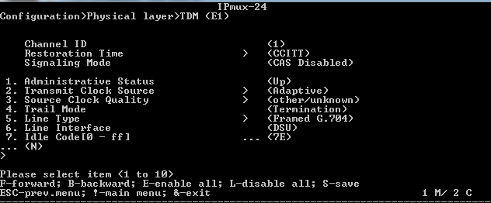

Configuration:

|  |  |
| --- | --- |
| Source Clock | Adaptive |
| Source Clock Quality | other/unknown |
| Line Type | Framed G.704 |

###### Configure PWE host IP and static route

1. Configure *PW IP 10.10.10.7* by navigating to:Root->configuration->Connection->PW Host IP

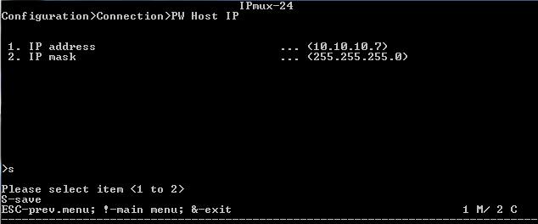

***Note****: in band management by telnet would be terminated.active it again.*

1. Add PWE Host IP to static Route
2. Root->Configuration

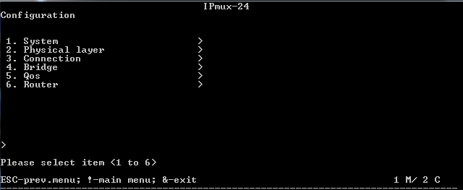

1. Configuration->Router

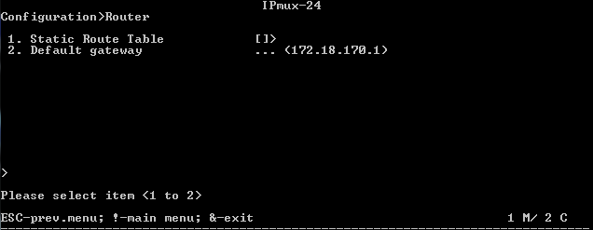

1. Add to static route a remote PWE IP 100.100.100.100, DG 10.10.10.7
2. Router->Static Route Tabel

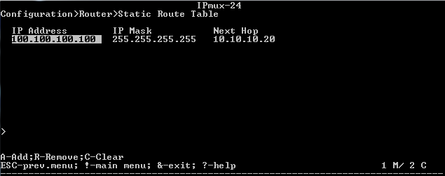

1. Press ‘a’ to Add a new entry to table

###### Configure Bundles, ID (label, udp port) 1,33,65,97

1. Change general parameters per Bundle ID

Configuration:

|  |  |
| --- | --- |
| PW Type | CESoPSN |
| PSN Type | UDP/IP |

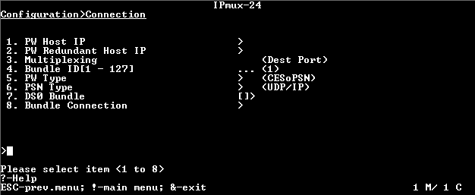

1. Set DS0 Bundle (cross connect)

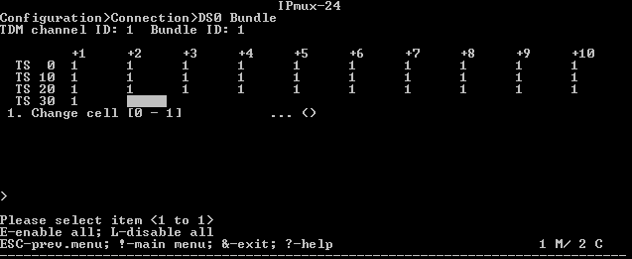

1. Press ‘a’ to enable all Time Slots.
2. For each PWE configure:

|  |  |
| --- | --- |
| Destination IP Address | 100.100.100.100 |
| Connection status | Enable |
| Destination Bundle | 1,33,65,97 (per bundle) |
| TDM Bytes in Frame | 8 |
| OAM Connectivity | Disable |
| Jitter Buffer | 3 |
| Far End Type | E1 |
| VLAN Tagging | Enable |
| VLAN ID | 401 |
| VLAN Priority | 7 |

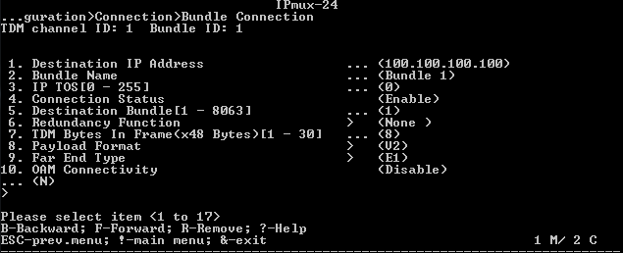

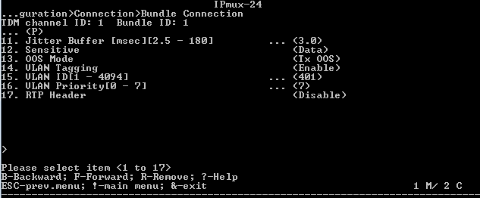

###### Bridge support PW Vlan

1. Root->Configuration-Bridge

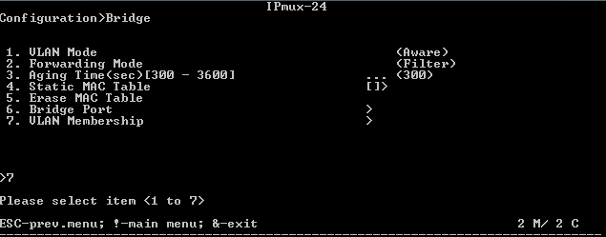

1. Add VLAN 401 to Egress Unmodified Ports 4

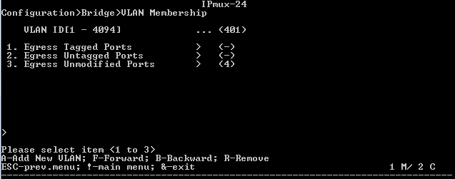

1. Press ‘a’ to add
   1. ETX-5 ↔ ETX-205 Services Configuration

##### ETX-5 Services PW5-PW8

|  |
| --- |
| # ***************************************************  # *********************** LVC ***********************  # ***************************************************  #----------------------------------------------------  # Port 1/1  #----------------------------------------------------  #*********************** STM-1 **************************  configure port sdh-sonet 1/1 aug 1 tug3 1 vc12 2 2 no shutdown  configure port sdh-sonet 1/1 aug 1 tug3 1 vc12 2 3 no shutdown  configure port sdh-sonet 1/1 aug 1 tug3 1 vc12 3 1 no shutdown  configure port sdh-sonet 1/1 aug 1 tug3 1 vc12 3 2 no shutdown  # *************************************************************  # *************************************************************  # ************************* E1 CONFIG *************************  # *************************************************************  config port e1 1/1/5 line-type g732n  config port e1 1/1/6 line-type g732n  config port e1 1/1/7 line-type g732n  config port e1 1/1/8 line-type g732n  #----------------------------------------------------  # E1 Clock Port 1/1_1/2  #----------------------------------------------------  configure port e1 1/1/5 tx-clock-source domain 1  configure port e1 1/1/6 tx-clock-source domain 1  configure port e1 1/1/7 tx-clock-source domain 1  configure port e1 1/1/8 tx-clock-source domain 1  #----------------------------------------------------  # SDH Port 1/1  #----------------------------------------------------  # ***************************************************  # ****************** E1 Admin Up ********************  # ***************************************************  config port e1 1/1/5 no shutdown  config port e1 1/1/6 no shutdown  config port e1 1/1/7 no shutdown  config port e1 1/1/8 no shutdown  # ***************************************************  # *************** Peer configuration*****************  # ***************************************************  config peer 2 ip 10.10.10.8 name HQ  exit all  #  #*******************************************************  #******************* port 1/1 STM-1 pw *******************  #*******************************************************  #************************ HQ ********************************  config pwe pw 5 type ces-psn-data psn udp-over-ip  label in 130 out 130  peer 2  tdm-payload size 248 rate 31  jitter-buffer 10000  no oam  psn-oos 1-bit  no shutdown  exit all  config pwe pw 6 type ces-psn-data psn udp-over-ip  label in 131 out 131  peer 2  tdm-payload size 248 rate 31  jitter-buffer 10000  no oam  psn-oos 1-bit  no shutdown  exit all  config pwe pw 7 type ces-psn-data psn udp-over-ip  label in 132 out 132  peer 2  tdm-payload size 248 rate 31  jitter-buffer 10000  no oam  psn-oos 1-bit  no shutdown  exit all  config pwe pw 8 type ces-psn-data psn udp-over-ip  label in 133 out 133  peer 2  tdm-payload size 248 rate 31  jitter-buffer 10000  no oam  psn-oos 1-bit  no shutdown  exit all  #************************ HQ_END ********************************  # ***************************************************  # ****************** PW assignment ******************  # ***************************************************  config cross-connect pw-tdm pw 5 e1 1/1/5 time-slots 1..31  config cross-connect pw-tdm pw 6 e1 1/1/6 time-slots 1..31  config cross-connect pw-tdm pw 7 e1 1/1/7 time-slots 1..31  config cross-connect pw-tdm pw 8 e1 1/1/8 time-slots 1..31 |

##### ETX-205 Services PW5-PW8

|  |
| --- |
| #*************************** SVI for PW ***********************  configure port svi 2  no shutdown  exit all  #*************************** PW Flows ************************  configure flows  classifier-profile match_all match-any  match all  exit all  configure flows  classifier-profile VLAN401 match-any  match vlan 401  exit all  config flows flow "p1_svi2"  classifier "VLAN401"  vlan-tag pop vlan  ingress-port ethernet 1  egress-port svi 2 queue 0  no shutdown  exit all  config flows flow "svi2_p1"  classifier "match_all"  vlan-tag push vlan 401 p-bit fixed 0  ingress-port svi 2  egress-port ethernet 1 queue 0 block 0/1  no shutdown  exit all  #*************************** PW peer ************************  config peer 1 ip 100.100.100.100 name Aggregation_POP  #*************************** DS1 - Port Configuration *****************  config port ds1 1  frame-type e1  exit all  config port ds1 2  frame-type e1  exit all  config port ds1 3  frame-type e1  exit all  config port ds1 4  frame-type e1  exit all    #*************************** PWE - Configuration *****************  config pwe pw 1 type ces-psn-data psn udp-over-ip  peer 1  jitter-buffer 15000  label in 130 out 130  vlan priority 0  tdm-payload size 248 rate 31  psn-oos 1-bit  pm-enable  no shutdown  exit all  config pwe pw 2 type ces-psn-data psn udp-over-ip  peer 1  jitter-buffer 15000  label in 131 out 131  vlan priority 0  tdm-payload size 248 rate 31  psn-oos 1-bit  pm-enable  no shutdown  exit all  config pwe pw 3 type ces-psn-data psn udp-over-ip  peer 1  jitter-buffer 15000  label in 132 out 132  vlan priority 0  tdm-payload size 248 rate 31  psn-oos 1-bit  pm-enable  no shutdown  exit all  config pwe pw 4 type ces-psn-data psn udp-over-ip  peer 1  jitter-buffer 15000  label in 133 out 133  vlan priority 0  tdm-payload size 248 rate 31  psn-oos 1-bit  pm-enable  no shutdown  exit all  #******************** e1 - Port Configuration ***************  config port e1 1  no shutdown  tx-clock-source domain 1  line-type g732n  exit all  config port e1 2  no shutdown  tx-clock-source domain 1  line-type g732n  exit all  config port e1 3  no shutdown  tx-clock-source domain 1  line-type g732n  exit all  config port e1 4  no shutdown  tx-clock-source domain 1  line-type g732n  exit all  #******************** Cross-connect - Configuration ***********  config cross-connect pw-tdm pw 1 e1 1 time-slots 1..31  config cross-connect pw-tdm pw 2 e1 2 time-slots 1..31  config cross-connect pw-tdm pw 3 e1 3 time-slots 1..31  config cross-connect pw-tdm pw 4 e1 4 time-slots 1..31  exit all  #******************** Router interface ***********  config router 1  name "Router#1"  interface 2  address 10.10.10.8/24  bind svi 2  no management-access  no shutdown  exit  static-route 100.100.100.100/32 address 10.10.10.20  exit all |

* 1. ETX-5 ↔ MiTOP Services Configuration

##### ETX-5 Service PW9

|  |
| --- |
| # ***************************************************  # *********************** LVC ***********************  # ***************************************************  #----------------------------------------------------  # Port 1/1  #----------------------------------------------------  #*********************** STM-1 **************************  configure port sdh-sonet 1/1 aug 1 tug3 1 vc12 3 3 no shutdown  # *************************************************************  # *************************************************************  # ************************* E1 CONFIG *************************  # *************************************************************  config port e1 1/1/9 line-type g732n  #----------------------------------------------------  # E1 Clock Port 1/1_1/2  #----------------------------------------------------  configure port e1 1/1/9 tx-clock-source domain 1  #----------------------------------------------------  # SDH Port 1/1  #----------------------------------------------------  # ***************************************************  # ****************** E1 Admin Up ********************  # ***************************************************  config port e1 1/1/9 no shutdown  # ***************************************************  # *************** Peer configuration*****************  # ***************************************************  config peer 3 ip 10.10.10.9 name MiTOP  #  #*******************************************************  #******************* port 1/1 STM-1 pw *******************  #*******************************************************  #************************ MiTOP ********************************  config pwe pw 9 type ces-psn-data psn udp-over-ip  label in 134 out 134  peer 3  tdm-payload size 248 rate 31  jitter-buffer 10000  no oam  psn-oos 1-bit  no shutdown  exit all  #******************** MiTOP_END ********************************  # ***************************************************  # ****************** PW assignment ******************  # ***************************************************  config cross-connect pw-tdm pw 9 e1 1/1/9 time-slots 1..31 |

##### MiTOP Service PW9

###### Hot Keys

* Previous menu – go back one step menu
* Refresh – reload changed values
* Save – save changed parameter

###### Configure TDM port

1. Root->Configuration->Physical Ports



1. Press on ‘E1’ and configure, press ‘SAVE’ button

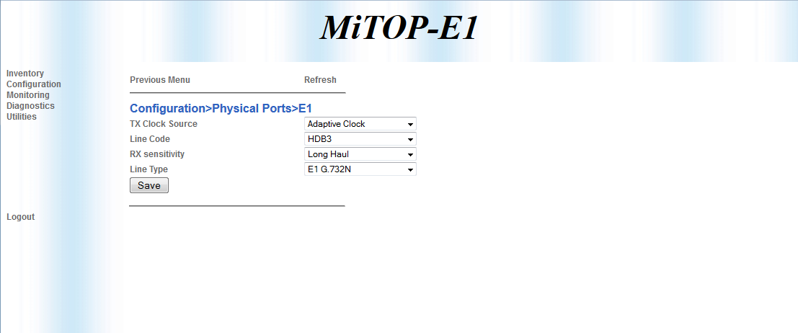

Configuration:

|  |  |
| --- | --- |
| TX Clock Source | Adaptive Clock |
| Line Code | HDB3 |
| RX sensitivity | Long Haul |
| Line Type | E1 G.732N |

###### Configure PEER IP

1. Root->Configuration->Multi service over PSN

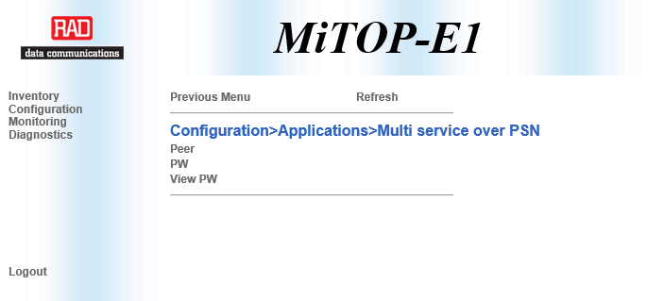

1. Multi service over PSN ->Peer

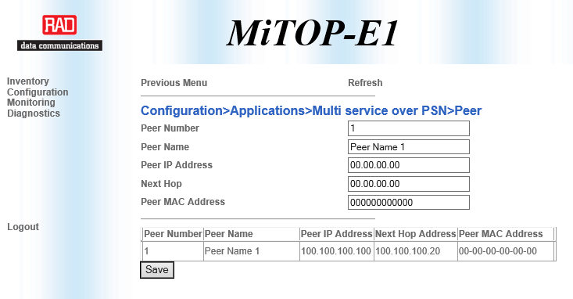

1. Change configuration and press ‘SAVE’ button

Configuration:

|  |  |
| --- | --- |
| Peer IP Address | 100.100.100.100 |
| Next Hope | 10.10.10.20 |

###### General PW Configuration

1. Press ‘Previous Menu’
2. (Root->Configuration->Multi service over PSN->PW->General Configuration)

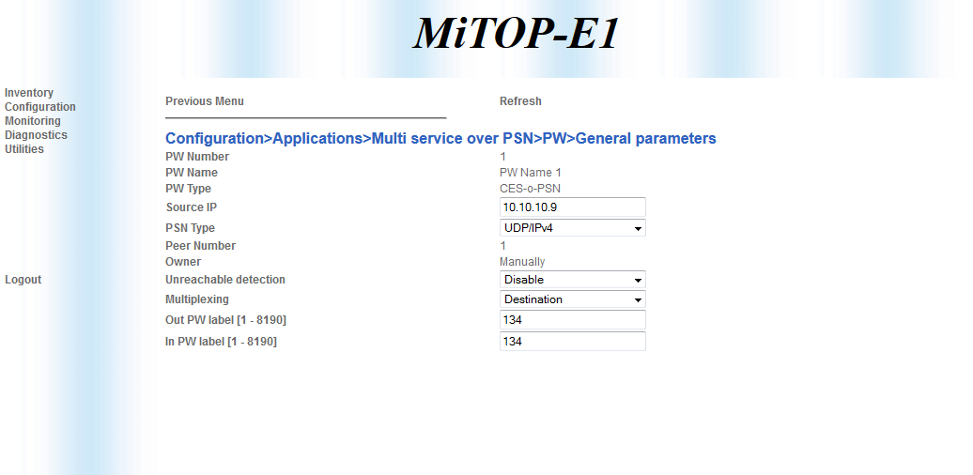

Configuration:

|  |  |
| --- | --- |
| Source IP Address | 10.10.10.9 |
| Multiplexing | Destination |
| OAM | Disable |
| Out PW label | 134 |
| In PW label | 134 |

###### PSN parameters

1. Press ‘Previous Menu’
2. (Root->Configuration->Multi service over PSN->PW->PSN parameters)

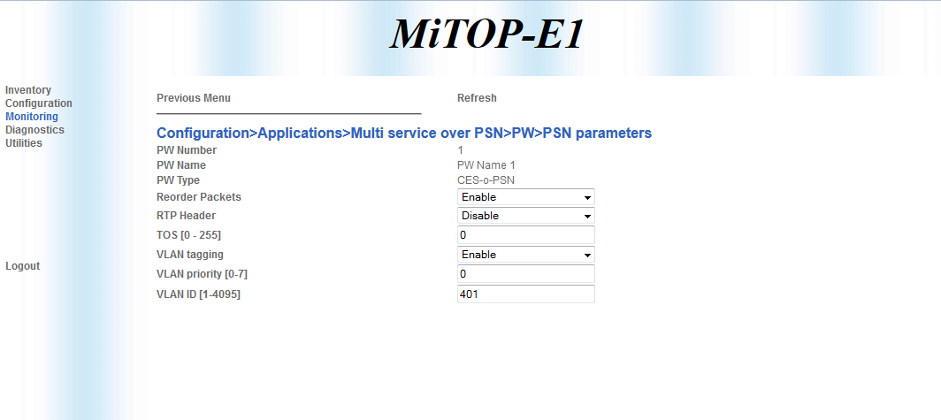

Configuration:

|  |  |
| --- | --- |
| Reorder Packets | Enable |
| RTP Header | Disable |
| TOS | 0 |
| VLAN tagging | Enable |
| VLAN priority | 0 |
| VLAN ID | 401 |

###### Service parameters

1. Press ‘Previous Menu’
2. (Root->Configuration->Multi service over PSN->PW->Service parameters)

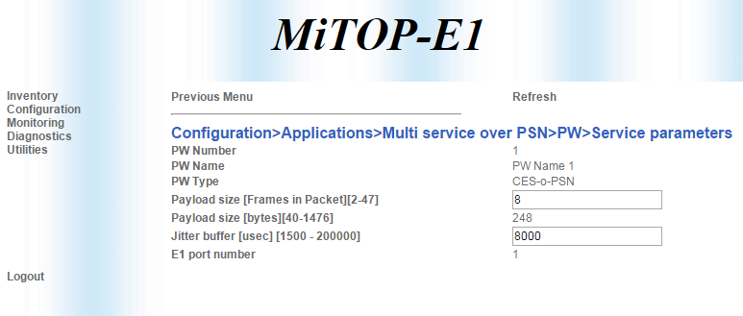

Configuration:

|  |  |
| --- | --- |
| Payload size | 8 |
| Jitter buffer | 8000 |

###### PW configuration

1. Press ‘Previous Menu’
2. (Root->Configuration->Multi service over PSN->PW)

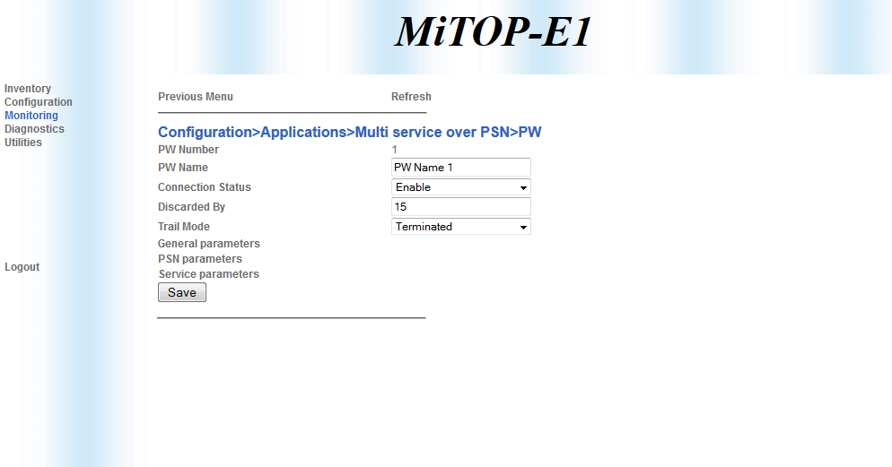

Configuration:

|  |  |
| --- | --- |
| Connection status | Enable |
| Trail Mode | Terminated |

1. Press ‘SAVE’ button.
   1. ETX-5 ↔ LA-210 Services Configuration

##### ETX-5 Service PW10

|  |
| --- |
| # ***************************************************  # *********************** LVC ***********************  # ***************************************************  #----------------------------------------------------  # Port 1/1  #----------------------------------------------------  #*********************** STM-1 **************************  configure port sdh-sonet 1/1 aug 1 tug3 1 vc12 4 1 no shutdown  # *************************************************************  # *************************************************************  # ************************* E1 CONFIG *************************  # *************************************************************  config port e1 1/1/10 line-type g732n  #----------------------------------------------------  # E1 Clock Port 1/1_1/2  #----------------------------------------------------  configure port e1 1/1/10 tx-clock-source domain 1  #----------------------------------------------------  # SDH Port 1/1  #----------------------------------------------------  # ***************************************************  # ****************** E1 Admin Up ********************  # ***************************************************  config port e1 1/1/10 no shutdown  # ***************************************************  # *************** Peer configuration*****************  # ***************************************************  config peer 4 ip 10.10.10.10 name LA210  #  #*******************************************************  #******************* port 1/1 STM-1 pw *******************  #*******************************************************  #********************** LA210_E1 ********************************  config pwe pw 10 type ces-psn-data psn udp-over-ip  label in 135 out 135  peer 4  tdm-payload size 248 rate 31  jitter-buffer 10000  no oam  psn-oos 1-bit  no shutdown  exit all  # ***************************************************  # ****************** PW assignment ******************  # ***************************************************  config cross-connect pw-tdm pw 10 e1 1/1/10 time-slots 1..31 |

##### LA-210 Service PW10

|  |
| --- |
| config router 1  peer 1 ip 100.100.100.100 name "Peer-1"  static-route 100.100.100.100/32 address 10.10.10.20  exit all  config pwe pw 1 type ces-psn-data psn udp-over-ip manually  name "Put your string here"  peer 1  label in 135 out 135  tdm-payload size 248 rate 31  jitter-buffer 100000  udp-mux-method dst-port  no shutdown  exit  exit all  configure system clock recovered 1 adaptive  pw 1  exit all  echo "Cross Connect"  # Cross Connect  configure cross-connect  pw-tdm pw 1 e1 1 time-slots 1..31  exit |

1. Appendix E – SONET – SATOP (MEF 8)
   1. ETX-5 ↔ IPmux-24 Services Configuration

##### ETX-5 Services PW1-PW4

|  |
| --- |
| # ***************************************************  # *********************** LVC ***********************  # ***************************************************  #----------------------------------------------------  # Port 1/1  #----------------------------------------------------  #**************************** STS1-1 **************************  configure port sdh-sonet 1/1 oc3 1 sts1 1 vt1-5 1 1 no shutdown  configure port sdh-sonet 1/1 oc3 1 sts1 1 vt1-5 2 1 no shutdown  configure port sdh-sonet 1/1 oc3 1 sts1 1 vt1-5 3 1 no shutdown  configure port sdh-sonet 1/1 oc3 1 sts1 1 vt1-5 4 1 no shutdow  # *************************************************************  # ************************* T1 CONFIG *************************  # *************************************************************  config port t1 1/1/1 line-type unframed  config port t1 1/1/2 line-type unframed  config port t1 1/1/3 line-type unframed  config port t1 1/1/4 line-type unframed  #----------------------------------------------------  # SONET Port 1/1  #----------------------------------------------------  configure port t1 1/1/1 tx-clock-source domain 1  configure port t1 1/1/2 tx-clock-source domain 1  configure port t1 1/1/3 tx-clock-source domain 1  configure port t1 1/1/4 tx-clock-source domain 1  #----------------------------------------------------  # SONET Port 1/1  #----------------------------------------------------  # ***************************************************  # ****************** T1 Admin Up ********************  # ***************************************************  config port t1 1/1/1 no shutdown  config port t1 1/1/2 no shutdown  config port t1 1/1/3 no shutdown  config port t1 1/1/4 no shutdown  # ****************** PW SVI ********************  configure port svi 201 pw  exit all  # ***************************************************  # *************** Peer configuration*****************  # ***************************************************  config peer 1 mac 00-20-D2-26-46-CD name IPMUX24  exit all  #  #*******************************************************  #******************* port 3/1 oc3 pw *******************  #*******************************************************  #******************* IPMUX_24***************************  config pwe pw 1 type t1satop psn ethernet  label in 1 out 1  peer 1  egress-port svi 201  tdm-payload size 192  jitter-buffer 10000  no oam  psn-oos 1-bit  no shutdown  exit all  config pwe pw 2 type t1satop psn ethernet  label in 33 out 33  peer 1  egress-port svi 201  tdm-payload size 192  jitter-buffer 10000  no oam  psn-oos 1-bit  no shutdown  exit all  config pwe pw 3 type t1satop psn ethernet  label in 65 out 65  peer 1  egress-port svi 201  tdm-payload size 192  jitter-buffer 10000  no oam  psn-oos 1-bit  no shutdown  exit all  config pwe pw 4 type t1satop psn ethernet  label in 97 out 97  peer 1  egress-port svi 201  tdm-payload size 192  jitter-buffer 10000  no oam  psn-oos 1-bit  no shutdown  exit all  #******************* IPMUX_24_END ***************************  # ***************************************************  # ****************** PW assignment ******************  # ***************************************************  config cross-connect pw-tdm pw 1 t1 1/1/1  config cross-connect pw-tdm pw 2 t1 1/1/2  config cross-connect pw-tdm pw 3 t1 1/1/3  config cross-connect pw-tdm pw 4 t1 1/1/4  # ******************************************************  # ********** PW_to_ethernet main-a/1 **********  # ******************************************************  configure port svi 1 bridge  exit all  configure port svi 2 bridge  exit all  config bridge 1  port 1  bind svi 1  no shutdown  exit  port 2  bind svi 2  no shutdown  exit  vlan 401  tagged-egress 1..2  exit all  config flows classifier-profile "VLAN401" match-any  match vlan 401  exit all  configure flows flow ETH_main-a/1_SVI_Bridge  classifier VLAN401  ingress-port ethernet main-a/1  egress-port svi 2  no shutdown  exit all  configure flows flow SVI_Bridge_SVI_PW  classifier VLAN401  ingress-port svi 1  egress-port svi 201  vlan-tag pop vlan  no shutdown  exit all  configure flows flow SVI_PW_SVI_Bridge  classifier all  ingress-port svi 201  egress-port svi 1  vlan-tag push vlan 401 p-bit fixed 0  pm-enable  no shutdown  exit all  configure flows flow SVI_Bridge_ETH_main-a/1  classifier VLAN401  ingress-port svi 2  egress-port ethernet main-a/1 queue-map-profile QueueMapDefaultProfile block 0/2  pm-enable  no shutdown  exit all |

##### IPMUX-24 Service PW1-PW4

###### Configure 1-4 TDM ports

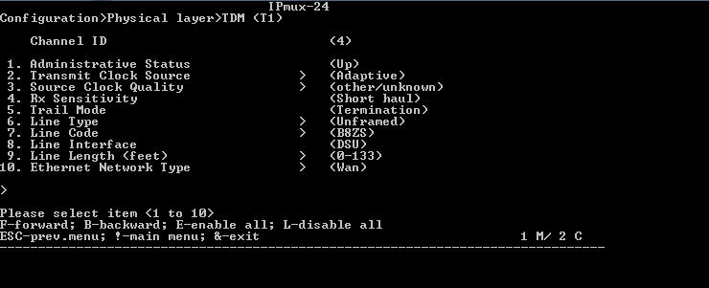

Hot Keys

* F-Forward, B-Backward - move from between ports 1-4
* N-Next, P-Previous – scroll down a configuration screen
* S-Save configuration , ESC-exit previous screen

Configuration:

|  |  |
| --- | --- |
| Source Clock | Adaptive |
| Source Clock Quality | other/unknown |
| Line Type | Unframed |

###### Configure PWE host IP and static route

1. Configure *PW IP 10.10.10.7* by navigating to:Root->configuration->Connection->PW Host IP



***Note****: in band management by telnet would be terminated.active it again.*

1. Add PWE Host IP to static Route
2. Root->Configuration



1. Configuration->Router



1. Add to static route a remote PWE IP 100.100.100.100, DG 10.10.10.7
2. Router->Static Route Tabel



1. Press ‘a’ to Add a new entry to table

###### Configure Bundles, ID (label, udp port) 1,33,65,97

1. Change general parameters per Bundle ID

Configuration:

|  |  |
| --- | --- |
| PW Type | SAToP |
| PSN Type | MAC/ETH |

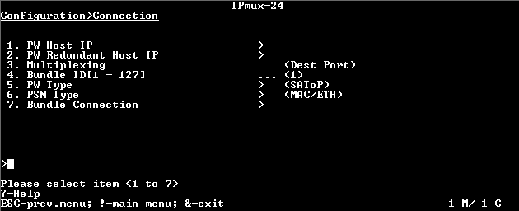

1. For each PWE configure:

|  |  |
| --- | --- |
| Destination IP Address | 20.20.20.20 |
| Connection status | Enable |
| Destination Bundle | 1,33,65,97 (per bundle) |
| Next Hop Type | MAC |
| Next Hop MAC Address | 00-20-D2-F5-82-08 |
| TDM Bytes in Packet | 192 |
| Jitter Buffer | 3 |
| VLAN Tagging | Enable |
| VLAN ID | 401 |
| VLAN Priority | 7 |

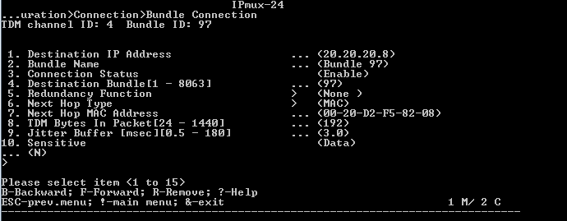

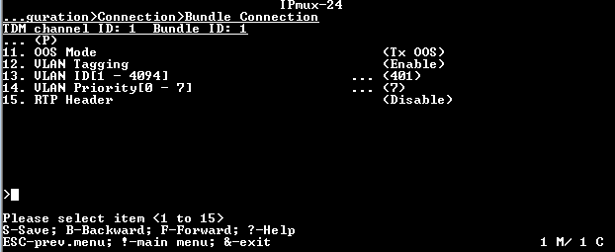

###### Bridge support PW Vlan

1. Root->Configuration-Bridge



1. Add VLAN 401 to Egress Unmodified Ports 4



1. Press ‘a’ to add
   1. ETX-5 ↔ ETX-205 Services Configuration

##### ETX-5 Services PW5-PW8

|  |
| --- |
| # ***************************************************  # *********************** LVC ***********************  # ***************************************************  #----------------------------------------------------  # Port 1/1  #----------------------------------------------------  #**************************** STS1-1 **************************  configure port sdh-sonet 1/1 oc3 1 sts1 1 vt1-5 5 1 no shutdown  configure port sdh-sonet 1/1 oc3 1 sts1 1 vt1-5 6 1 no shutdown  configure port sdh-sonet 1/1 oc3 1 sts1 1 vt1-5 7 1 no shutdown  # *************************************************************  # ************************* T1 CONFIG *************************  # *************************************************************  config port t1 1/1/5 line-type unframed  config port t1 1/1/6 line-type unframed  config port t1 1/1/7 line-type unframed  config port t1 1/1/8 line-type unframed  #----------------------------------------------------  # SONET Port 1/1  #----------------------------------------------------  configure port t1 1/1/5 tx-clock-source domain 1  configure port t1 1/1/6 tx-clock-source domain 1  configure port t1 1/1/7 tx-clock-source domain 1  configure port t1 1/1/8 tx-clock-source domain 1  #----------------------------------------------------  # SONET Port 1/1  #----------------------------------------------------  # ***************************************************  # ****************** T1 Admin Up ********************  # ***************************************************  config port t1 1/1/5 no shutdown  config port t1 1/1/6 no shutdown  config port t1 1/1/7 no shutdown  config port t1 1/1/8 no shutdown  # ***************************************************  # *************** Peer configuration*****************  # ***************************************************  config peer 2 mac 00-20-D2-51-CE-D2 name HQ  exit all  #  #*******************************************************  #******************* port 3/1 oc3 pw *******************  #*******************************************************  #************************ HQ ********************************  config pwe pw 5 type t1satop psn ethernet  label in 130 out 130  peer 2  egress-port svi 201  tdm-payload size 192  jitter-buffer 10000  no oam  psn-oos 1-bit  no shutdown  exit all  config pwe pw 6 type t1satop psn ethernet  label in 131 out 131  peer 2  egress-port svi 201  tdm-payload size 192  jitter-buffer 10000  no oam  psn-oos 1-bit  no shutdown  exit all  config pwe pw 7 type t1satop psn ethernet  label in 132 out 132  peer 2  egress-port svi 201  tdm-payload size 192  jitter-buffer 10000  no oam  psn-oos 1-bit  no shutdown  exit all  config pwe pw 8 type t1satop psn ethernet  label in 133 out 133  peer 2  egress-port svi 201  tdm-payload size 192  jitter-buffer 10000  no oam  psn-oos 1-bit  no shutdown  exit all  #************************ HQ_END ********************************  # ***************************************************  # ****************** PW assignment ******************  # ***************************************************  config cross-connect pw-tdm pw 5 t1 1/1/5  config cross-connect pw-tdm pw 6 t1 1/1/6  config cross-connect pw-tdm pw 7 t1 1/1/7  config cross-connect pw-tdm pw 8 t1 1/1/8 |

##### ETX-205 Services PW5-PW8

|  |
| --- |
| configure port svi 2  no shutdown  exit all  configure flows  classifier-profile match_all match-any  match all  exit all  configure flows  classifier-profile VLAN401 match-any  match vlan 401  exit all  config flows flow "p1_svi2"  classifier "VLAN401"  vlan-tag pop vlan  ingress-port ethernet 1  egress-port svi 2 queue 0  no shutdown  exit all  config flows flow "svi2_p1"  classifier "match_all"  vlan-tag push vlan 401 p-bit fixed 0  ingress-port svi 2  egress-port ethernet 1 queue 0 block 0/1  no shutdown  exit all  config peer 1 mac 00-20-D2-F5-82-08 name Aggregation_POP  # DS1 - Port Configuration  config port ds1 1  frame-type t1  exit all  config port ds1 2  frame-type t1  exit all  config port ds1 3  frame-type t1  exit all  config port ds1 4  frame-type t1  exit all    # PWE - Configuration  config pwe pw 1 type t1satop psn ethernet  peer 1  label in 130 out 130  vlan priority 0  tdm-payload size 192  psn-oos 1-bit  egress-port svi 2  pm-enable  no shutdown  exit all  config pwe pw 2 type t1satop psn ethernet  peer 1  label in 131 out 131  vlan priority 0  tdm-payload size 192  psn-oos 1-bit  egress-port svi 2  pm-enable  no shutdown  exit all  config pwe pw 3 type t1satop psn ethernet  peer 1  label in 132 out 132  vlan priority 0  tdm-payload size 192  psn-oos 1-bit  egress-port svi 2  pm-enable  no shutdown  exit all  config pwe pw 4 type t1satop psn ethernet  peer 1  label in 133 out 133  vlan priority 0  tdm-payload size 192  psn-oos 1-bit  egress-port svi 2  pm-enable  no shutdown  exit all  config cross-connect pw-tdm pw 1 t1 1  config cross-connect pw-tdm pw 2 t1 2  config cross-connect pw-tdm pw 3 t1 3  config cross-connect pw-tdm pw 4 t1 4  exit all  # T1 - Port Configuration  config port t1 1  no shutdown  tx-clock-source domain 1  line-type unframed  exit all  config port t1 2  no shutdown  tx-clock-source domain 1  line-type unframed  exit all  config port t1 3  no shutdown  tx-clock-source domain 1  line-type unframed  exit all  config port t1 4  no shutdown  tx-clock-source domain 1  line-type unframed  exit all |

* 1. ETX-5 ↔ MiTOP Services Configuration

##### ETX-5 Service PW9

|  |
| --- |
| # ***************************************************  # *********************** LVC ***********************  # ***************************************************  #----------------------------------------------------  # Port 1/1  #----------------------------------------------------  #**************************** STS1-1 **************************    configure port sdh-sonet 1/1 oc3 1 sts1 1 vt1-5 1 2 no shutdown  # *************************************************************  # ************************* T1 CONFIG *************************  # *************************************************************  config port t1 1/1/9 line-type unframed  #----------------------------------------------------  # SONET Port 1/1  #----------------------------------------------------  configure port t1 1/1/9 tx-clock-source domain 1  #----------------------------------------------------  # SONET Port 1/1  #----------------------------------------------------  # ***************************************************  # ****************** T1 Admin Up ********************  # ***************************************************  config port t1 1/1/9 no shutdown  # ***************************************************  # *************** Peer configuration*****************  # ***************************************************  config peer 3 mac 00-20-D2-42-84-3F name MiTOP  exit all  #  #*******************************************************  #******************* port 3/1 oc3 pw *******************  #*******************************************************  #************************ MiTOP ********************************  config pwe pw 9 type t1satop psn ethernet  label in 134 out 134  peer 3  egress-port svi 201  tdm-payload size 192  jitter-buffer 10000  no oam  psn-oos 1-bit  no shutdown  exit all  #******************** MiTOP_END ********************************  # ***************************************************  # ****************** PW assignment ******************  # ***************************************************  config cross-connect pw-tdm pw 9 t1 1/1/9 |

##### MiTOP Service PW9

###### Hot Keys

* Previous menu – go back one step menu
* Refresh – reload changed values
* Save – save changed parameter

###### Configure TDM port

1. Root->Configuration->Physical Ports

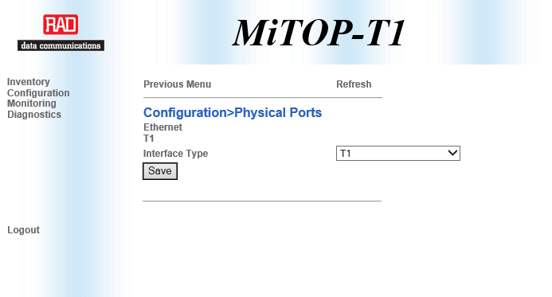

1. Press on ‘T1’ and configure, press ‘SAVE’ button

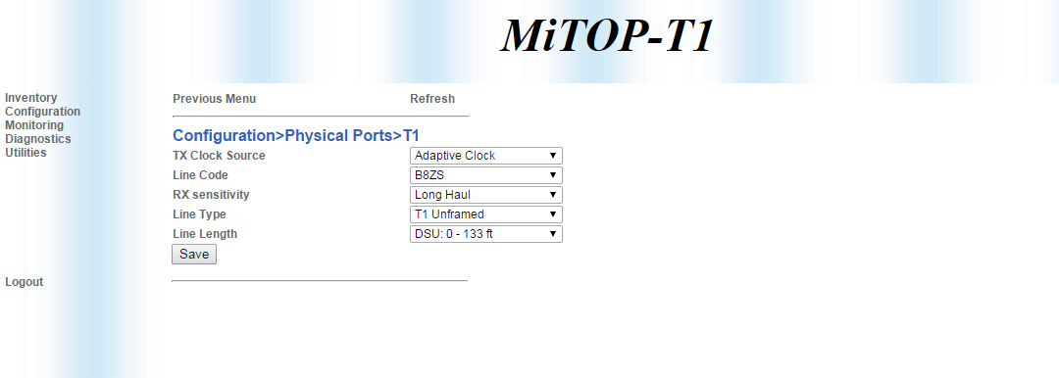

Configuration:

|  |  |
| --- | --- |
| TX Clock Source | Adaptive Cloc |
| Line Code | B8ZS |
| RX sensitivity | Long Haul |
| Line Type | T1 Unframed |
| Line Length | DSU:0 – 133 ft |

###### Configure PEER IP

1. Root->Configuration->Multi service over PSN

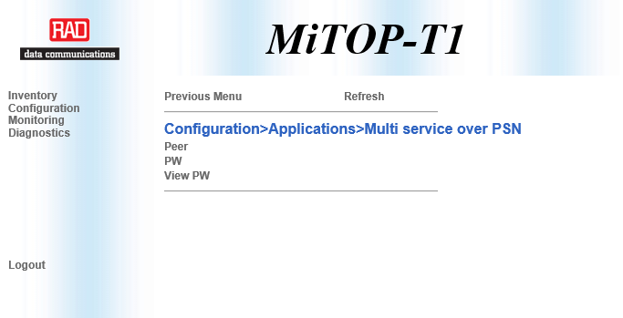

1. Multi service over PSN ->Peer

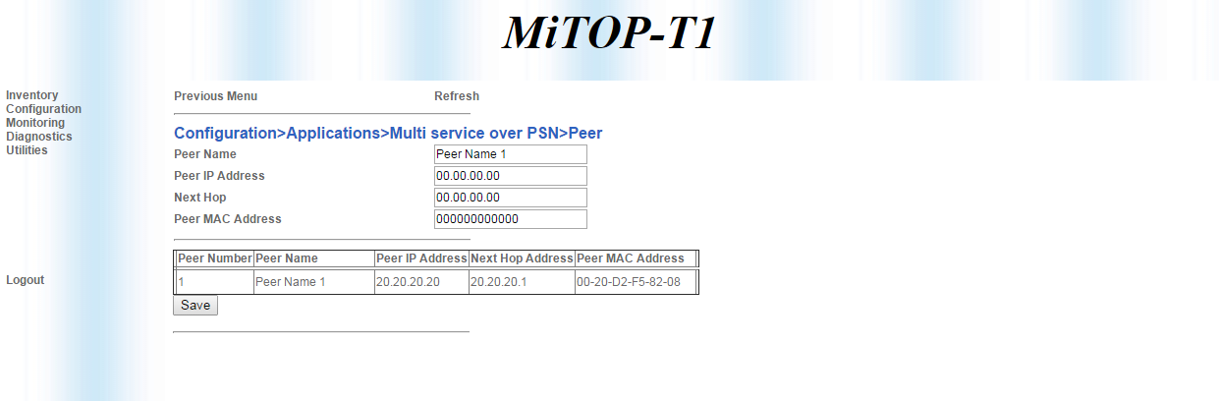

1. Change configuration and press ‘SAVE’ button

Configuration:

|  |  |
| --- | --- |
| Peer IP Address | 20.20.20.20 |
| Next Hope | 20.20.20.1 |
| Peer MAC Address | 00-20-D2-F5-82-08 |

###### General PW Configuration

1. Press ‘Previous Menu’
2. (Root->Configuration->Multi service over PSN->PW->General Configuration)

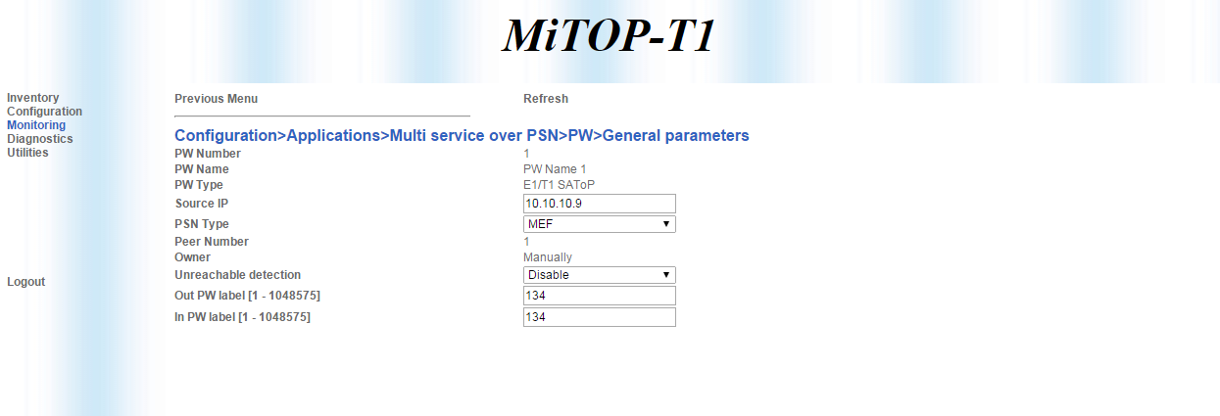

Configuration:

|  |  |
| --- | --- |
| Source IP Address | 10.10.10.9 |
| PSN Type | MEF |
| Multiplexing | Destination |
| OAM | Disable |
| Out PW label | 134 |
| In PW label | 134 |

###### PSN parameters

1. Press ‘Previous Menu’
2. (Root->Configuration->Multi service over PSN->PW->PSN parameters)

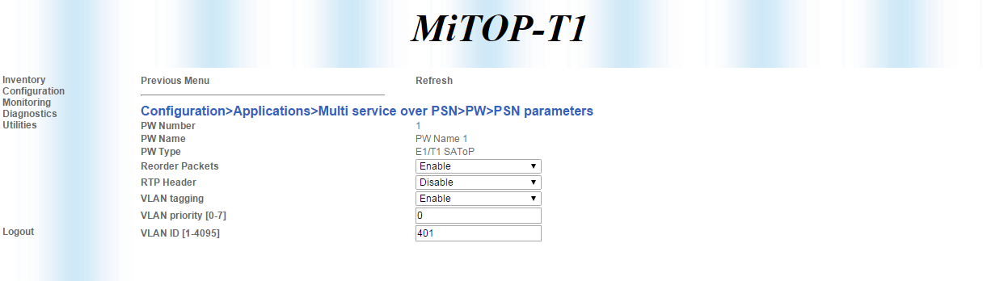

Configuration:

|  |  |
| --- | --- |
| Reorder Packets | Enable |
| RTP Header | Disable |
| TOS | 0 |
| VLAN tagging | Enable |
| VLAN priority | 0 |
| VLAN ID | 401 |

###### Service parameters

1. Press ‘Previous Menu’
2. (Root->Configuration->Multi service over PSN->PW->Service parameters)

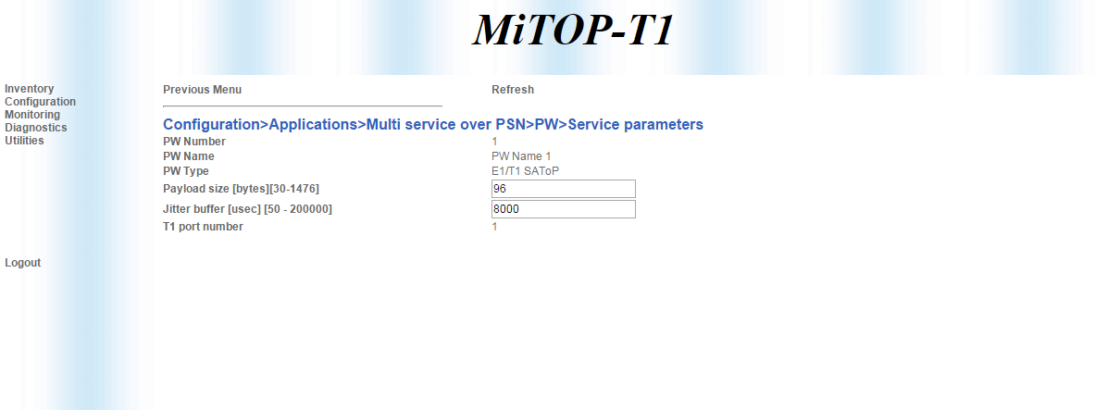

Configuration:

|  |  |
| --- | --- |
| Payload size | 96 |
| Jitter buffer | 8000 |

###### PW configuration

1. Press ‘Previous Menu’

(Root->Configuration->Multi service over PSN->PW)

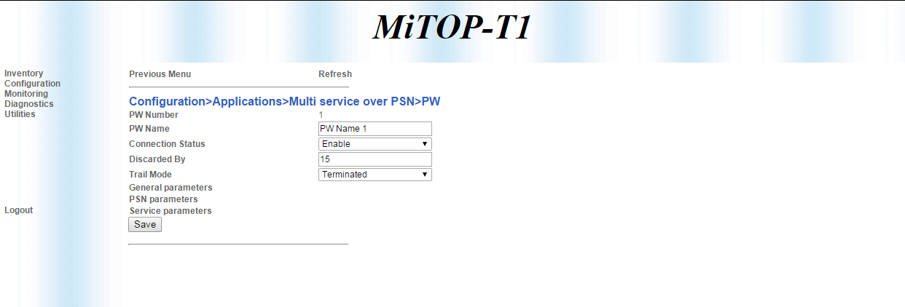

Configuration:

|  |  |
| --- | --- |
| Connection status | Enable |
| Trail Mode | Terminated |

1. Press ‘SAVE’ button.