SHENZHEN TIBTRONIX Technology Co., Ltd.

TSPL1GG0D-XX
1.25Gb/s 160km CWDM SFP Transceiver Hot Pluggable, Duplex LC, +3.3V, 1270nm～1610nm, CWDM DFB, Single-mode, DDM
2014/1/1

Shenzhen Tibtronix Technology Co., Ltd. 3/F,12th Building, Nangang 1st Industrial Park, Baimang Xili, Songbai Road, Nanshan District, Shenzhen, China Tel: +86 755 23316583 Fax: +86 755 29810056 E-mail: sales@tibtronix.com http://www.tibtronix.com

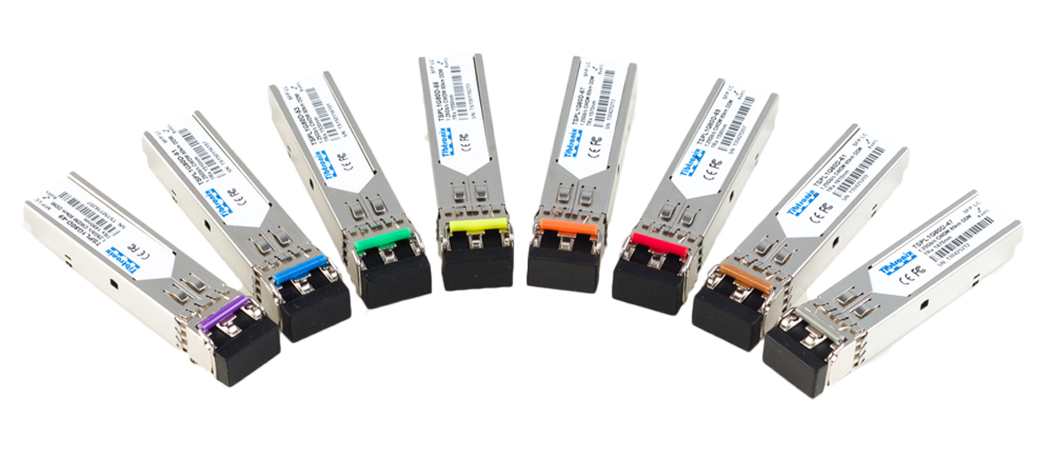

Features:
- Data-rate of 1.25Gbps operation
- 18-Wavelength CWDM DFB LD Transmitter from
- 1270nm to 1610nm, with Step 20nm
- Compliant with SFP MSA and SFF-8472
- Compatible with SONET OC-24-LR-1
- Compatible with RoHS
- +3.3V single power supply
- Hot-Pluggable SFP Footprint Duplex LC
- Operating case temperature
Standard : 0°C to +70°C
Extended: -10°C to +85°C
Industrial: -40°C to +85°C

Applications:
- Gigabit Ethernet
- Fiber Channel Switch Infrastructure
- Router/Server interface
- Other optical transmission systems

Description:
The TSPL1GG0D-xx series single mode transceiver is small form factor pluggable module for duplex optical data communications such as Gigabit Ethernet 1000BASE-EZX and Fiber Channel 1x SM-LC-L FC-PI. It is with the SFP 20-pin connector to allow hot plug capability. This module is designed for single mode fiber and operates at a nominal wavelength of CWDM wavelength. There are eighteen center wavelengths available from 1270nm to 1610nm, with each step 20nm.
The transmitter section uses a multiple quantum well CWDM DFB laser and is a class 1 laser compliant according to International Safety Standard IEC-60825. The receiver section uses an integrated InGaAs detector preamplifier (IDP) mounted in an optical header and a limiting post-amplifier IC. The TSPL1GG0D-xx series are designed to be compliant with SFF-8472.

  - Absolute Maximum Ratings
Parameter | Symbol | Min. | Typical | Max. | Unit
Storage Temperature | T_{S} | -10 |  | +85 | °C
Supply Voltage | V_{CC} | -0.5 |  | 3.6 | V
Relative Humidity | RH | 0 |  | 90 | %

  - Recommended Operating Environment:
Parameter | Symbol | Min. | Typical | Max. | Unit
Case operating Temperature | Tc | 0 |  | +70 | °C
Supply Voltage | V_{CC} | 3.15 |  | 3.45 | V
Supply Current | Icc |  |  | 300 | mA
Data rate | GBE |  | 1.25 |  | Gbps
 | FC |  | 1.063 |  | Gbps

  - Electrical Characteristics(T_{OP} =0 to 70°C, VCC = 3.135 to 3.465 Volts)
Parameter |  | Symbol | Min. | Typical | Max. | Unit | Note
Transmitter Section:
Input differential impedance |  | R_{in} | 85 | 100 | 115 | Ω | 
Single ended data input swing |  | V_{in PP} | 400 |  | 2000 | mVp-p
Transmit Disable Voltage |  | V_{D} | 2.0 |  | Vcc | V
Transmit Enable Voltage |  | V_{EN} | 0 |  | 0.8 | V
Tx Fault | Fault | Tx_f | 2.0 |  |  | V
 | Normal | Tx_n | 0 |  |  | V
Receiver Section:
Single ended data output swing |  | Vout,pp | 370 |  | 1800 | mv
LOS Fault |  | V_{losfault} | 2 |  | Vcc | V
LOS Normal |  | V_{los norm} | 0 |  | 0.8 | V

  - Optical Parameters(T_{OP} =0 to 70°C, VCC = 3.135 to 3.465 Volts)
Parameter | Symbol | Min. | Typical | Max. | Unit | Note
Transmitter Section:
Center Wavelength | λ_{c} | λ-6 | λ | λ+7.5 | nm
Spectral Width(-20dB) | △λ |  |  | 1 | nm
Side Mode Suppression Ratio | SMSR | 30 |  |  | dB
Optical Output Power | P_{out} | 2 |  | +5 | dBm | 1
Optical Rise/Fall Time | t_{r} / t_{f} |  |  | 260 | ps | 2
Extinction Ratio | ER | 8.2 |  |  | dB
Eye Mask for Optical Output | Compliant with IEEE802.3z(class 1 laser safety)
Receiver Section:
Optical Input Wavelength | λ_{c} | 1260 |  | 1620 | nm
Receiver Overload | P_{ol} | -8 |  |  | dBm | 3
RX Sensitivity | Sen |  |  | -34 | dBm | 3
RX_LOS Assert | LOS _{A} | -41 |  |  | dBm
RX_LOS De-assert | LOS _{D} |  |  | -34 | dBm
RX_LOS Hysteresis | LOS _{H} | 0.5 |  |  | dB
General Specifications:
Data Rate | BR |  | 1.063/1.25 |  | Gb/s
Bit Error Rate | BER |  |  | 10⁻¹²
Max. Supported Link Length on 9/125μm SMF@1.25Gb/s | L_{MAX} |  | 160 |  | km
Total System Budget | LB | 24 |  |  | dB
Note
- The optical power is launched into SMF.
- 20-80%.
- Measured with PRBS 2⁷⁻¹ at 10⁻¹² BER

  - Pin Assignment
Diagram of Host Board Connector Block Pin Numbers and Name
Diagram of Host Board Connector Block Pin Numbers and Names

  - Pin Function Definitions
Pin No | Name | Function | Plug Seq | Notes
1 | VeeT | Transmitter Ground | 1 | 1
2 | TX Fault | Transmitter Fault Indication | 3
3 | TX Disable | Transmitter Disable | 3 | 2
4 | MOD-DEF2 | Module Definition | 2 | 3
5 | MOD-DEF1 | Module Definition 1 | 3 | 3
6 | MOD-DEF0 | Module Definition 0 | 3 | 3
7 | Rate Select | Not Connected | 3 | 4
8 | LOS | Loss of Signal | 3 | 5
9 | VeeR | Receiver Ground | 1 | 1
10 | VeeR | Receiver Ground | 1 | 1
11 | VeeR | Receiver Ground |  | 1
12 | RD- | Inv. Received Data Out | 3 | 6
13 | RD+ | Received Data Out | 3 | 6
14 | VeeR | Receiver Ground | 3 | 1
15 | VccR | Receiver Power | 2 | 1
16 | VccT | Transmitter Power | 2
17 | VeeT | Transmitter Ground | 1
18 | TD+ | Transmit Data In | 3 | 6
19 | TD- | Inv. Transmit In | 3 | 6
20 | VeeT | Transmitter Ground | 1
Notes:
- Circuit ground is internally isolated from chassis ground.
- Laser output disabled on TDIS >2.0V or open, enabled on TDIS <0.8V.
- Should be pulled up with 4.7k - 10 kohms on host board to a voltage between 2.0V and 3.6V. MOD_DEF(0) pulls line low to indicate module is plugged in.
- Rate select is not used
- LOS is open collector output. Should be pulled up with 4.7k – 10 kohms on host board to a voltage between 2.0V and 3.6V. Logic 0 indicates normal operation; logic 1 indicates loss of signal.
- AC Coupled

  - SFP Module EEPROM Information and Management
The SFP modules implement the 2-wire serial communication protocol as defined in the SFP -8472. The serial ID information of the SFP modules and Digital Diagnostic Monitor parameters can be accessed through the I²C interface at address A0h and A2h. The memory is mapped in Table 1. Detailed ID information (A0h) is listed in Table 2. And the DDM specification at address A2h. For more details of the memory map and byte definitions, please refer to the SFF-8472, “Digital Diagnostic Monitoring Interface for Optical Transceivers”. The DDM parameters have been internally calibrated.

Table 1. Digital Diagnostic Memory Map (Specific Data Field Descriptions)

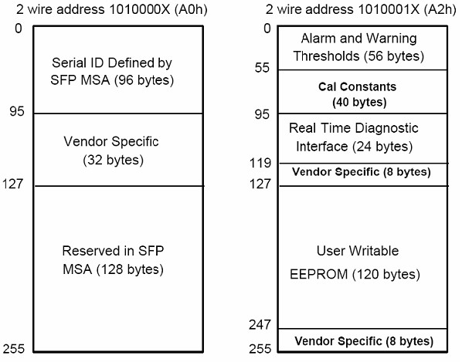
Table 2 - EEPROM Serial ID Memory Contents (A0h)
Data Address | Length  (Byte) | Name of  Length | Description and Contents
Base ID Fields
0 | 1 | Identifier | Type of Serial transceiver (03h=SFP)
1 | 1 | Reserved | Extended identifier of type serial transceiver (04h)
2 | 1 | Connector | Code of optical connector type (07=LC)
3-10 | 8 | Transceiver
11 | 1 | Encoding | NRZ(03h)
12 | 1 | BR, Nominal | Nominal baud rate, unit of 100Mbps
13-14 | 2 | Reserved | (0000h)
15 | 1 | Length(9um) | Link length supported for 9/125um fiber, units of 100m
16 | 1 | Length(50um) | Link length supported for 50/125um fiber, units of 10m
17 | 1 | Length(62.5um) | Link length supported for 62.5/125um fiber, units of 10m
18 | 1 | Length(Copper) | Link length supported for copper, units of meters
19 | 1 | Reserved
20-35 | 16 | Vendor Name | SFP vendor name: TIBTRONIX
36 | 1 | Reserved
37-39 | 3 | Vendor OUI | SFP transceiver vendor OUI ID
40-55 | 16 | Vendor PN | Part Number: “TSPL1GG0D-xx” (ASCII)
56-59 | 4 | Vendor rev | Revision level for part number
60-62 | 3 | Reserved
63 | 1 | CCID | Least significant byte of sum of data in address 0-62
Extended ID Fields
64-65 | 2 | Option | Indicates which optical SFP signals are implemented  (001Ah = LOS, TX_FAULT, TX_DISABLE all supported)
66 | 1 | BR, max | Upper bit rate margin, units of %
67 | 1 | BR, min | Lower bit rate margin, units of %
68-83 | 16 | Vendor SN | Serial number (ASCII)
84-91 | 8 | Date code | TIBTRONIX’s Manufacturing date code
92-94 | 3 | Reserved
95 | 1 | CCEX | Check code for the extended ID Fields (addresses 64 to 94)
Vendor Specific ID Fields
96-127 | 32 | Readable | TIBTRONIX specific date, read only
128-255 | 128 | Reserved | Reserved for SFF-8079

  - Digital Diagnostic Monitor Characteristics
Data Address | Parameter | Accuracy | Unit
96-97 | Transceiver Internal Temperature | ±3.0 | °C
98-99 | VCC3 Internal Supply Voltage | ±3.0 | %
100-101 | Laser Bias Current | ±10 | %
102-103 | Tx Output Power | ±3.0 | dBm
104-105 | Rx Input Power | ±3.0 | dBm

  - Regulatory Compliance
The TSPL1GG0D-xx complies with international Electromagnetic Compatibility (EMC) and international safety requirements and standards (see details in Table following).

Electrostatic Discharge  (ESD) to the Electrical Pins | MIL-STD-883E  Method 3015.7 | Class 1(>1000 V)
Electrostatic Discharge (ESD)  to the Duplex LC Receptacle | IEC 61000-4-2  GR-1089-CORE | Compatible with standards
Electromagnetic  Interference (EMI) | FCC Part 15 Class B  EN55022 Class B (CISPR 22B)  VCCI Class B | Compatible with standards
Laser Eye Safety | FDA 21CFR 1040.10 and 1040.11  EN60950, EN (IEC) 60825-1,2 | Compatible with Class 1 laser  product.

  - Recommended Circuit
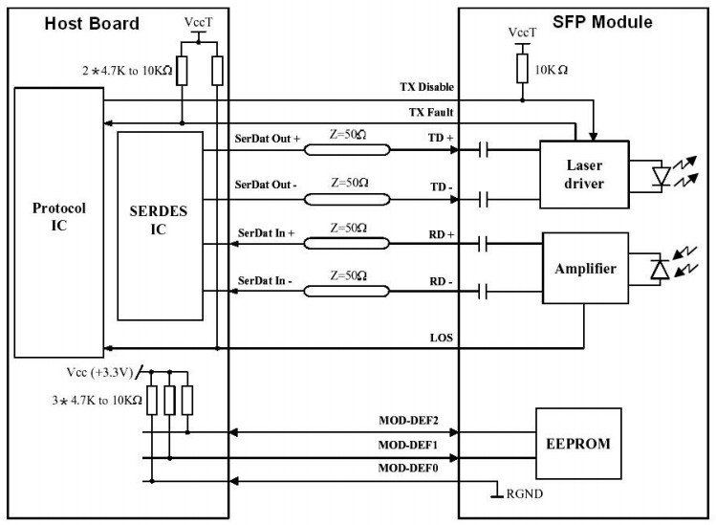
SFP Host Recommended Circuit

  - Mechanical Dimensions
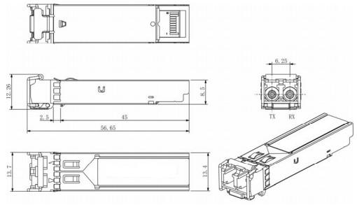
Mechanical Drawing

- Order Information:
In the Part No. of TSPL1GG0D-xx, xx stands for central wavelength, such as:

27: for 1270nm, 29: for 1290nm, 31: for 1310nm,…… 61: for 1610nm.

